Components of IoT Applications
Learning Diary

Week 1 – Introduction to Computer Networks and IoT
- Define following terms and concepts shortly:
  - Network bandwidth
Network bandwidth means the maximum amount of data that a network connection can carry during a certain time. It is normally measured in bits per second (bps), for example 100 Mbps or 1 Gbps. I can think about bandwidth like the width of a road, a wider road has capacity for more traffic.
  - Network throughput
Network throughput is the amount of data that is transferred successfully through the network during a certain time. Throughput is normally lower than the maximum bandwidth because network congestion, Wi-Fi interference, packet loss, or other limitations can reduce the real performance. For example, a 100 Mbps connection may give only 75 Mbps of actual throughput.
  - Packet loss and jitter
Packet loss happens when some data packets do not reach their destination. Too much packet loss can cause missing information, slow downloads, poor video quality or breaks in a voice call.
Jitter means that the delay between arriving packets is not constant. This is especially important in real-time communication such as VoIP, online gaming and video calls, because high jitter can make audio or video unstable.
  - bps vs Bps
bps means bits per second, while Bps means bytes per second. One byte contains 8 bits, so the difference between the lowercase b and uppercase B is important. For example, 200 Mbps is equal to a maximum of 25 MB/s if we only consider the data rate.
  - Protocol payload
Protocol payload is the useful data that a protocol is carrying. It does not include protocol headers or other control information. For example, when a network packet carries part of a web page, that web page data is part of the payload.

  - Protocol overhead (especially for resource-contrained IoT purposes
Protocol overhead means the extra information needed to deliver and manage the actual data, such as headers, addresses, control fields and acknowledgements. This is important in resource-constrained IoT devices because these devices may have limited battery, memory, processing power and network capacity. If a small IoT message has a large amount of overhead, more energy and network time are used to transfer only a small amount of useful data.
  - Spanning Tree Protocol
Spanning Tree Protocol is a Layer 2 protocol used to prevent loops in switched Ethernet networks. If there are several possible paths between switches, STP can block some redundant paths and create a loop-free logical topology. This is important because Ethernet loops can create broadcast storms and make the network unusable.
  - Collision domain
A collision domain is an area of a network where devices using a shared medium may interfere with each other if they transmit at the same time. In old Ethernet networks using a hub, all connected devices were inside the same collision domain. A modern switch separates the ports into different collision domains, and full-duplex switched Ethernet does not use normal Ethernet collision handling.
  - Broadcast domain
A broadcast domain is the part of a Layer 2 network where a broadcast frame can reach all devices in that domain. Routers and Layer 3 boundaries separate broadcast domains. VLANs can also be used to create separate logical broadcast domains on the same switching infrastructure.
  - SOHO network
SOHO means Small Office/Home Office. A SOHO network is normally a small network with a limited number of computers, phones, printers and other devices. A typical home router may provide routing, Ethernet switching, Wi-Fi and firewall functions in one device.
  - MAC (physical) address
A MAC address is normally a 48-bit identifier used by a network interface for communication at the Data Link layer. It is commonly written in hexadecimal form, for example 8C:16:45:12:34:56. Modern devices can also use locally generated or randomized MAC addresses, so a visible MAC address is not always a permanent hardware identifier.

  - Physical layer protocol data unit (PDU)
At the Physical layer, data is represented as bits or a bit stream. The physical medium carries these bits by using electrical, optical or radio signals. For example, Ethernet cable uses electrical signals while Wi-Fi transmits information using radio waves.
  - MAC layer protocol data unit (PDU)
At the MAC sublayer, the protocol data unit is normally called a frame. An Ethernet frame contains information such as source and destination MAC addresses, the carried payload and error-detection information. The frame allows data to be delivered between devices on the local network.
  - Half-duplex vs Full-duplex
Half-duplex communication allows data to travel in both directions, but only one direction can transmit at a time. Full-duplex communication allows both sides to send and receive at the same time. Modern switched Ethernet normally uses full-duplex communication.
  - Ethernet auto-negotiation
Ethernet auto-negotiation allows two connected Ethernet devices to automatically advertise their capabilities and agree on suitable link settings. These settings can include the connection speed and duplex mode. This helps the two devices create the best compatible Ethernet connection without manually setting both ends.
  - Hidden node problem (wireless)
The hidden-node problem can happen when two wireless devices can communicate with the same access point but cannot hear each other directly. Both devices may think that the wireless channel is free and transmit at the same time, which can cause interference or lost frames. Mechanisms such as RTS/CTS can help to reduce this problem.
  - Networking physical vs logical topology
Physical topology describes how network devices, cables and other physical connections are actually arranged. Logical topology describes how data moves between devices and how the network is logically organised. For example, devices may physically connect to the same switches but be separated logically into different VLANs.

  - TIA/EIA-568 and ISO/IEC_11801
TIA-568, which is also commonly called TIA/EIA-568 in older material, is a structured cabling standard widely used for telecommunications cabling. ISO/IEC 11801 is an international standard for generic cabling in customer premises. These standards help different manufacturers and installations to follow compatible cabling requirements.
  - Ethernet cabling categories. For example, CAT 6
Ethernet twisted-pair cables are divided into categories according to their electrical performance, for example Cat 5e, Cat 6 and Cat 6A. Cat 6 is specified for frequencies up to 250 MHz and is commonly used for Gigabit Ethernet up to 100 metres. It can also support 10 Gigabit Ethernet over shorter distances, while Cat 6A is designed to support 10 Gigabit Ethernet over the full 100-metre channel.
  - 8P8C (RJ45)
8P8C means 8 positions and 8 contacts. It is the modular connector commonly used with twisted-pair Ethernet cables. People normally call this connector RJ45, although technically 8P8C describes the physical connector and RJ45 originally referred to a particular telecommunications interface.
  - Wifi AD HOC
Wi-Fi ad hoc mode allows wireless devices to communicate directly with each other without using a wireless access point. It can be useful for creating a small temporary peer-to-peer wireless network. It is different from the normal infrastructure mode, where devices connect through a Wi-Fi access point.
  - IEEE 802.11ac, 802.11ax, 802.11be
IEEE 802.11ac is commonly known as Wi-Fi 5 and mainly operates in the 5 GHz band. It improved wireless speed by using technologies such as wider channels and multiple antennas.
IEEE 802.11ax is known as Wi-Fi 6, while Wi-Fi 6E extends this technology into the 6 GHz band. It improves network efficiency and is especially useful when many wireless devices are using the same network.

IEEE 802.11be is associated with Wi-Fi 7. It provides much higher possible throughput, wider channels and features such as Multi-Link Operation, which can use multiple wireless links more efficiently. It is designed to improve speed, latency and performance in busy wireless networks.
- Estimate how long does it take to download 3 TB file from cloud based backup service if network download throughput is 200 Mbps for actual payload (i.e. data)?
For this calculation, I use decimal units because TB normally means decimal terabytes.
1 TB = 1,000,000,000,000 bytes
Therefore: 3 TB = 3,000,000,000,000 bytes, Because 1 byte = 8 bits:
=3,000,000,000,000 × 8
= 24,000,000,000,000 bits
The given actual payload throughput is: 200 Mbps = 200,000,000 bits per second
I calculate the download time by using:
Time = Data size / Throughput
Time = 24,000,000,000,000 bits / 200,000,000 bits/s
Time = 120,000 seconds
Then I convert seconds to hours:
=120,000 / 3600
= 33.33 hours
0.33 hour × 60
≈ 20 minutes

Therefore, downloading a 3 TB file at a constant actual payload throughput of 200 Mbps would take approximately 120,000 seconds, or 33 hours and 20 minutes.
In real use, the download may take longer because the throughput may not stay at 200 Mbps all the time. Network congestion, Wi-Fi conditions, packet retransmissions, cloud-server performance and disk speed can change the transfer rate. Since the question already gives 200 Mbps as actual payload throughput, protocol overhead should not be added again to this calculation.

- Locate the MAC address of your mobile phone, laptop wifi interface or some other networked IT device
  - How did you find it?
Device used: My Windows laptop.
How I found the MAC address: I opened Command Prompt in Windows and used the following command
ipconfig /all
From the output, I found the section named "Wireless LAN adapter Wi-Fi". Under this section, I looked for "Physical Address", which shows the MAC address of the Wi-Fi interface. For privacy, I replaced the final 24 bits, which are the last three hexadecimal pairs, with zeros. My masked MAC address:
Physical Address. . . . . . . . . : D0-3C-1F-00-00-00

  - List the MAC address in hex format (such as f0:1f:af:cf:d9:1a), but replace last 24 bits with zeros for your privacy
Physical Address. . . . . . . . . : D0-3C-1F-00-00-00

  - Use OUI MAC address list(s) or lookup tools, and determine the device/chipset vendor of that MAC address. For example, that f0:1f:af:cf:d9:1a is Dell inc.
I used the first 24 bits of my MAC address, D0:3C:1F, for the OUI lookup.
The lookup result showed: OUI: D0:3C:1F
Vendor: Intel Corporate
I also checked the Wi-Fi adapter information using the ipconfig /all command. The adapter description was: Intel(R) Wireless-AC 9560 160MHz
Therefore, the OUI lookup result matches the Wi-Fi adapter information shown by Windows. The network adapter is an Intel wireless adapter.

- Describe shortly what are these network devices, functions, and services
  - Repeater
A repeater receives a weak or degraded signal and regenerates it so the signal can continue over a longer distance. It does not understand MAC addresses or IP addresses.
Main OSI layer: Layer 1 – Physical layer.
  - Hub (multiport repeater)
A hub is basically a repeater with several Ethernet ports. When it receives a signal on one port, it repeats the signal to the other ports without deciding which device actually needs the data. Hubs are old technology and have mostly been replaced by switches.
Main OSI layer: Layer 1 – Physical layer.
  - Bridge
A bridge connects network segments and forwards or filters Ethernet frames according to MAC addresses. It can learn which MAC addresses exist on each side and avoid forwarding unnecessary traffic.Main OSI layer: Layer 2 – Data Link layer.
  - Access switch
An access switch connects end devices such as computers, printers, IP phones and wireless access points to the local network. A normal access switch forwards Ethernet frames using MAC addresses, although some models also provide Layer 3 functions. Main OSI layer: Mainly Layer 2 – Data Link layer.
  - Core switch
A core switch is a high-capacity switch used in the central part or backbone of a larger network. It connects different access or distribution parts of the network and needs to handle large amounts of traffic quickly. Main OSI layers: Layer 2 and often Layer 3.
  - Edge router
An edge router is located at the boundary of a network and connects the internal network to another network, such as an ISP or the Internet. It makes routing decisions using IP addresses. Main OSI layer: Layer 3 – Network layer.
  - Core router
A core router is a high-performance router used inside a large network or service-provider backbone. Its main task is to move large amounts of IP traffic efficiently between networks. Main OSI layer: Layer 3 – Network layer.
  - Firewall
A firewall controls incoming and outgoing network traffic according to security rules. Traditional firewalls mainly inspect IP addresses, protocols and ports, while modern firewalls can also inspect application-level traffic. Main OSI layers: Usually Layers 3 and 4, and modern firewalls can also operate at Layer
  - Wifi AP
A Wi-Fi access point provides a wireless connection for devices such as laptops and mobile phones. It normally bridges wireless 802.11 traffic to a wired Ethernet network. Main OSI layers: Mainly Layers 1 and 2.
  - WLAN AP controller
A WLAN controller centrally manages several wireless access points. It can control settings such as SSIDs, security policies, radio channels, transmit power and roaming. This is useful in large organisations where managing every access point separately would be difficult. Relevant layers: It performs network management and control functions across several layers, while Wi-Fi traffic itself mainly uses Layers 1 and 2.
  - Network TAP
A Network TAP, or Test Access Point, is a device used to make a copy of network traffic for monitoring and analysis. It allows tools such as packet analysers or security monitoring systems to observe traffic without normally changing the original communication. Main OSI layer: A basic passive TAP operates mainly at Layer 1 – Physical layer.
- RFC assignments
  - What are RFCs?
RFC means Request for Comments. RFCs are numbered documents used to document Internet protocols, technical specifications, operational practices and other Internet-related information. Not every RFC is an Internet standard; possible categories or statuses include Proposed Standard, Internet Standard, Best Current Practice, Informational, Experimental and Historic.
  - How many PPP related RFC documents can you find from rfc-editor website?
I searched the RFC Editor website using the search term "PPP". Search term: PPP Search also obsolete/historic: Yes Search only Metadata and Abstract: No Number of search results: 638 Access date: 18 September 2026 The search returned 638 RFC documents containing or related to the term PPP. One example is RFC 3818, "IANA Considerations for the Point-to-Point Protocol (PPP)".
  - What is the current status of RFC1597? What is the number for updated, more recent RFC of same topic?
RFC 1597 is titled "Address Allocation for Private Internets". It is an Informational RFC, but it is now obsolete. RFC 1597 was obsoleted by RFC 1918, which covers the updated topic of private IPv4 address allocation.
  - When was RFC5218 released?
It was published in July 2008. The document discusses factors that can help or prevent an Internet protocol from becoming successful.
  - What is the meaning if RFC status is BCP?
BCP means Best Current Practice. A BCP RFC describes practices, procedures or recommendations that represent the Internet community's accepted current thinking. It is normally about how something should be operated or handled rather than only defining a new protocol specification.

  - List authors of the CoAP RFC (June 2014). What is the RFC number?
The Constrained Application Protocol (CoAP) is defined in RFC 7252. It was published in June 2014.
Authors: Zach Shelby / Klaus Hartke / Carsten Bormann
CoAP is designed for constrained environments such as IoT systems where devices and networks can have limited resources.
  - Twitch.tv provides IRC access to the stream chats. Which RFC defines the original Internet Relay Chat (IRC) Protocol?
The original Internet Relay Chat (IRC) Protocol is defined in RFC 1459, titled "Internet Relay Chat Protocol". It was written by J. Oikarinen and D. Reed and published in May 1993. RFC number: RFC 1459

- What is OSI model? Compare OSI model to TCP/IP model
The OSI model is a reference model that explains network communication by dividing it into seven layers. Each layer has its own responsibilities, which makes a network easier to understand and troubleshoot. For example, the Physical layer is responsible for transmitting bits, while the Network layer deals with logical addressing and routing.
The TCP/IP model is the practical model commonly used to describe communication on the Internet. I use the common four-layer TCP/IP model: Application, Transport, Internet and Network Access. The main difference is that OSI has seven layers, while TCP/IP combines several OSI functions into four larger layers. For example, the OSI Application, Presentation and Session layers are normally combined into the TCP/IP Application layer.
When data moves down the layers, each layer adds information needed by its protocol, which is called encapsulation. For a simple web request, the application creates the HTTP data, TCP can place the data into segments, IP carries it inside IP packets, and Ethernet or Wi-Fi carries the packets inside frames. Finally, the Physical layer sends the information as electrical, optical or radio signals. At the destination, this process happens in the opposite direction until the application receives the original data.
The OSI model is useful for learning and troubleshooting because a problem can be considered layer by layer. The TCP/IP model is more closely related to the protocols that are actually used for Internet communication.

- What are VLANs and IEEE 802.1Q?
A VLAN (Virtual Local Area Network) is a way to divide one physical network into separate logical networks. Devices can use the same physical switches but still belong to different broadcast domains. For example, a company can have VLAN 10 for employees and VLAN 20 for guest users. Normally, devices in different VLANs need a router or Layer 3 switch to communicate with each other.
IEEE 802.1Q is the standard used for VLAN tagging in Ethernet networks. It adds VLAN information to an Ethernet frame so that switches can identify which VLAN the frame belongs to. The VLAN ID field is 12 bits, and VLAN IDs 1–4094 are normally available for use. An access port normally connects an end device to one VLAN, while a trunk link can carry traffic for several VLANs between switches.
Example: An office can use VLAN 10 for staff computers and VLAN 20 for guest Wi-Fi. Both VLANs can use the same physical switching infrastructure, but their traffic is logically separated.
- Define following terms and concepts shortly:
  - ARP
ARP (Address Resolution Protocol) ARP is used in IPv4 networks to find the MAC address that belongs to a known IP address inside the local network. A device sends an ARP request asking which device owns a certain IP address, and the correct device replies with its MAC address. This allows Ethernet frames to be sent to the correct device on the local network.
  - ARP spoofing
ARP spoofing is a local network attack where a device sends false ARP messages to associate its own MAC address with the IP address of another device, such as the default gateway. As a result, traffic may be redirected through the attacker. This can be used for man-in-the-middle attacks, traffic monitoring or communication disruption.
  - HOP (networking)
A hop is one step in the path that a data packet takes from one network device to the next, usually between routers. Each router that forwards the packet toward its destination counts as one hop. Tools such as traceroute show the hops between my computer and a destination.
  - IP TTL
IP TTL is a field in the IPv4 header that limits how many router hops a packet can travel through. Each router decreases the TTL value by one, and when the value reaches zero, the packet is discarded. This prevents packets from circulating endlessly if a routing loop occurs.
  - IP TOS (DSCP)
IP TOS, or Type of Service, is a field in the IP header used to indicate how network traffic should be handled. In modern networks, this function is mainly provided by DSCP (Differentiated Services Code Point), which can mark packets with different priority levels. For example, voice traffic can be given higher priority than normal file downloads to reduce delay.
  - DHCP, DHCP relay
DHCP automatically gives network settings to devices, such as an IP address, subnet mask, default gateway and DNS server. This avoids the need to configure each device manually. A DHCP relay forwards DHCP messages between clients and a DHCP server when they are located in different networks or subnets.
  - WoL (Wake-on-LAN)
WoL (Wake-on-LAN) is a feature that allows a computer to be turned on remotely through the network. It works by sending a special network message called a "magic packet" to the computer's network adapter. The device must support WoL and be configured to listen for this packet while it is powered off or sleeping.
  - UPnP
UPnP (Universal Plug and Play) is a set of networking protocols that allows devices on the same local network to discover each other and communicate automatically. It can also allow applications to request network settings such as port mappings without manual configuration. This makes device setup easier, but poor UPnP configuration can also create security risks.
  - Traceroute / Tracepath
Traceroute and Tracepath are network diagnostic tools used to show the path that packets take from one device to a destination. They display the intermediate routers, or hops, along the route and can also show the delay to each hop. These tools are useful for finding where a network connection may be slow or failing.
  - Network Address Translation (NAT)
Network Address Translation (NAT) is a method used to translate private IP addresses inside a local network into a public IP address when accessing the Internet. It allows many devices in the same private network to share one public IPv4 address. NAT also hides the internal address structure from external networks.
  - Tier 1 and 2 networks
Tier 1 networks are very large global networks that can reach the whole Internet through settlement-free peering with other major networks. Tier 2 networks also operate large networks, but they usually need to buy Internet transit from another provider to reach some destinations. In simple terms, Tier 1 networks form part of the Internet backbone, while Tier 2 networks depend partly on larger providers.
  - Tier 3 ISP
A Tier 3 ISP is usually a smaller local or regional Internet service provider that buys Internet access from larger Tier 1 or Tier 2 providers. It mainly provides Internet connections to homes, small businesses and local customers. It normally does not have a large global backbone of its own.
  - Routing Autonomous System (AS or ASN for BGP)
An Autonomous System (AS) is a group of IP networks managed by one organisation under a common routing policy. Each AS is identified by an Autonomous System Number (ASN). BGP uses AS numbers to exchange routing information between different networks on the Internet.
  - 127.0.0.1 address
127.0.0.1 is the IPv4 loopback address. It refers to the same computer that is using it and is commonly called localhost. It is mainly used for testing network applications and services without sending traffic outside the device.
  - ::1 address
::1 is the IPv6 loopback address and has the same purpose as 127.0.0.1 in IPv4. It refers to the local device itself. It is commonly used for testing IPv6 applications and network services on the same computer.
  - 0.0.0.0/0 and ::/0 networks in the routing table
0.0.0.0/0 is the default route for IPv4, while ::/0 is the default route for IPv6. These routes match any destination that does not have a more specific route in the routing table. They are commonly used to send unknown traffic toward a default gateway.
  - Ranges of IPv4 multicast and experimental addresses
IPv4 multicast addresses are in the range 224.0.0.0 to 239.255.255.255, which is 224.0.0.0/4. They are used to send traffic from one sender to multiple receivers at the same time. The range 240.0.0.0 to 255.255.255.254 is reserved for experimental or future use.
- Search some information about AS1741
  - Which organisation or company advertises AS1741 with BGP?
AS1741 is operated by CSC/Funet (CSC – Tieteen tietotekniikan keskus Oy). Funet is the Finnish University and Research Network, which provides network services for Finnish research and education organisations.
  - List some public peering exchange points the AS1741 connects to?
According to PeeringDB, AS1741 connects to several public Internet exchange points in Finland. Some examples are:
• FICIX 1 – Espoo
• FICIX 2 – Helsinki
• FICIX 3 – Oulu
• TREX – Tampere
These exchange points allow AS1741 to exchange Internet traffic directly with other connected networks.
  - To which regional internet registry (RIR) the AS1741 belongs to?
AS1741 belongs to the RIPE NCC region. RIPE NCC is the Regional Internet Registry responsible for Europe, the Middle East and parts of Central Asia.
  - What is the contact email address/phone/web form if you would need to inform some security or abuse issues to the owner of the AS1741?
The official abuse contact listed for AS1741 in the RIPE Database is: cert@cert.funet.fi
This email address can be used to report security or network abuse issues related to AS1741.

- What it the difference between static and dynamic routing? Use example(s)
Static routing uses routes that are manually configured by a network administrator. These routes stay the same until someone changes them, so static routing is simple and suitable for small or stable networks. For example, a small office router can use a static default route to send all Internet traffic to the ISP gateway.
Dynamic routing uses routing protocols to automatically learn and update routes between routers. If the network changes or a link fails, routers can calculate a new path without manual configuration. For example, a large company network can use OSPF so routers automatically update their routing tables when the network topology changes.
- Describe briefly these dynamic routing protocols
  - RIP
RIP (Routing Information Protocol) is a distance-vector routing protocol that uses hop count to choose the best path. The maximum useful path is 15 hops, so RIP is mainly suitable for small networks. Routers periodically share routing information with their neighbours.
  - OSPF and IS-IS
OSPF (Open Shortest Path First) and IS-IS (Intermediate System to Intermediate System) are link-state routing protocols used inside an organisation or autonomous system. They build a view of the network topology and calculate efficient paths to destinations. Both are suitable for larger networks because they can react quickly to topology changes.
  - BGP
BGP (Border Gateway Protocol) is the main routing protocol used to exchange routing information between different Autonomous Systems on the Internet. It selects routes based on routing policies and attributes such as the AS path. BGP is highly scalable and is mainly used by Internet service providers and large organisations.
  - RPL (ripple)
RPL (Routing Protocol for Low-Power and Lossy Networks) is designed for IPv6-based IoT networks with devices that have limited power, memory and unreliable wireless links. It creates a routing structure called a DODAG to organise paths between devices. RPL is commonly used in wireless sensor and other constrained IoT networks.

- Create a DNS request (any tool such as ping, nslookup, whatever) to resolve the IP address of www.oamk.fi
  - Use some IP whois lookup web service to resolve which company is hosting and has that IP address and server? (www.oamk.fi)
I used the following command to resolve www.oamk.fi:
nslookup www.oamk.fi
The DNS query showed that www.oamk.fi is an alias for fi-haarla.seravo.com.
The returned IP addresses were:
IPv4:
95.217.104.240
95.217.107.33
IPv6:
2a01:4f9:4a:289e::2
2a01:4f9:4a:264f::2
The DNS server used by my computer was resolver1.dnaip.fi.
Access date: 19 September 2026
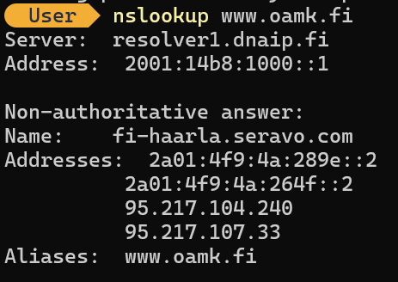

  - What is the inetnum or route/network (IP address range) the www.oamk.fi's IP address belongs to?
The IP address 95.217.104.240 belongs to Hetzner Online GmbH. The RIPE Database shows Hetzner Online GmbH as the responsible organisation for this IP address.
Source: RIPE Database
Access date: 19 September 2026
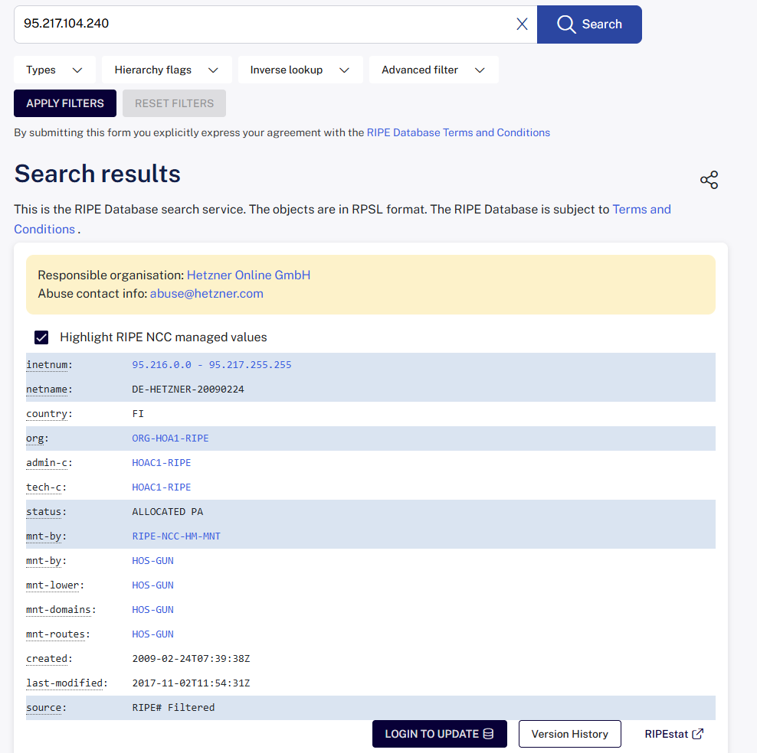

The RIPE Database shows that the IP address 95.217.104.240 belongs to the following inetnum range:
95.216.0.0 - 95.217.255.255
The BGP route shown for this address is:
95.217.0.0/16
The route is originated by AS24940, which belongs to Hetzner Online GmbH.
Source: RIPE Database
Access date: 19 September 2026
  - What is abuse contact email address of that network range?
The abuse contact email address for this network range is:
abuse@hetzner.com

This email address can be used to report security issues, spam or other network abuse related to the Hetzner network.
- Use traceroute (tracert in MS Windows command shell) to www.whitehouse.gov
  - What is the internet service provider's first router IP address near you? (it's most likely the 2nd router/hop, immediately after your home network)
The first responding router from my Internet service provider is:
oul1-bng1-inet.ip6.dnaip.fi
IPv6 address: 2001:14b8::6265
This is hop 1 and belongs to DNA, my Internet service provider.

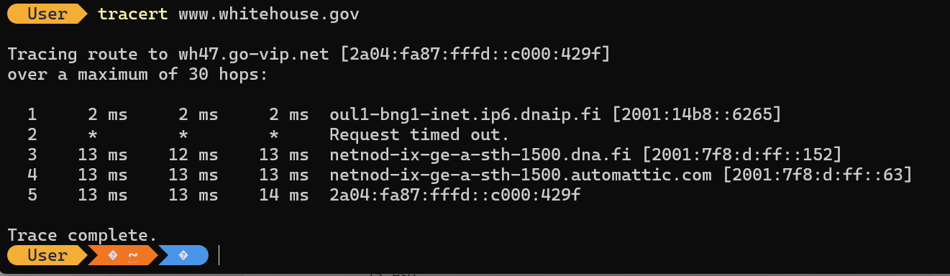

  - How many hops (routers) are there to the www.whitehouse.gov from your device?
The first responding router from my Internet service provider is:
oul1-bng1-inet.ip6.dnaip.fi
IPv6 address: 2001:14b8::6265
This is hop 1 in my traceroute and the hostname indicates that it belongs to DNA, my Internet service provider.
The traceroute reached www.whitehouse.gov at hop 5. Therefore, the destination was reached after 5 hop positions. There were 4 intermediate hop positions before the destination, although hop 2 did not respond and showed "Request timed out". The route still completed successfully.

  - Use traceroute again, but this time to Google's public DNS server in 8.8.8.8, and Quad9 DNS in 9.9.9.9. How far are those?
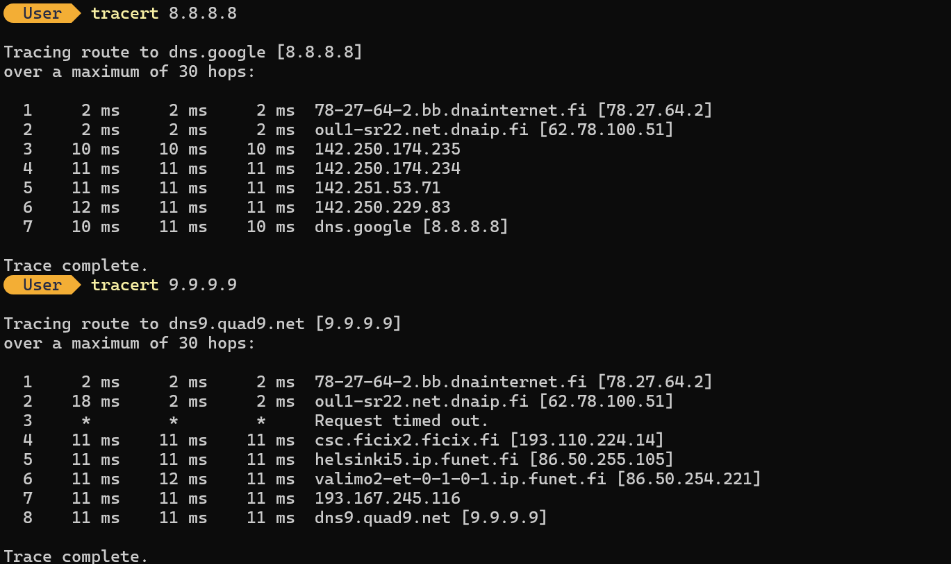
I used the command: tracert 8.8.8.8 The destination was reached at hop 7. The final round-trip time was approximately 10–11 ms. This means Google Public DNS was 7 hop positions away from my computer.
Quad9 DNS (9.9.9.9)
I used the command:
tracert 9.9.9.9
The destination was reached at hop 8. The final round-trip time was approximately 11 ms. Hop 3 did not respond and showed "Request timed out", but the traceroute continued successfully to the destination.

  - Why traceroute does not always work, and does not show the route up to the final destination IP, or there are timeouts for some routers (* is timeout)? For example, IP address of education.gov.au
Traceroute does not always show every router because some routers or firewalls are configured not to reply to traceroute packets. They may block ICMP messages, rate-limit the replies, or give lower priority to diagnostic traffic. When this happens, traceroute shows an asterisk (*) or "Request timed out" for that hop. This does not always mean that the network connection has failed, because the router may still forward normal traffic to the next destination.
The final destination may also not appear if the destination server or its firewall blocks traceroute-related packets. Therefore, missing hops or timeouts are normal in many networks and do not automatically indicate a network problem.
  - Use traceroute and DNS to estimate/guess from response DNS names, round trip times, and with IP whois lookups, where the web server reliefweb.int is located (continent, country or so)?
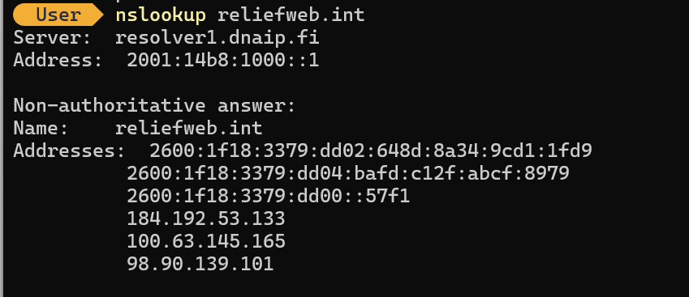
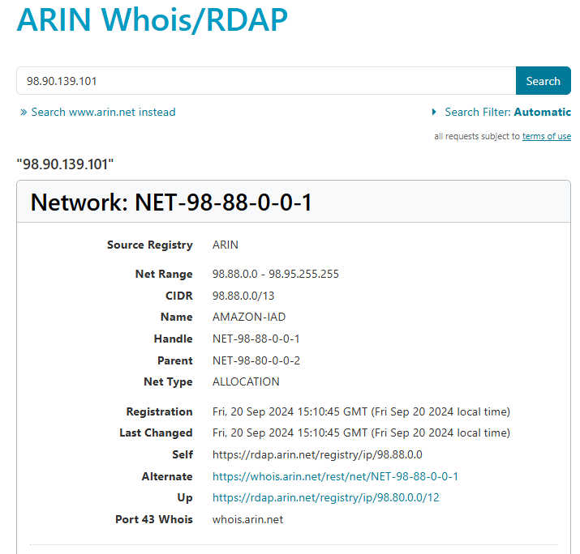
I used DNS, traceroute and an ARIN IP lookup to estimate the location of the reliefweb.int server.The DNS lookup returned several IP addresses. In my traceroute, the destination IP was 98.90.139.101.

The traceroute passed through routers with names indicating Stockholm (sto), Copenhagen (cph), Hamburg (ham), Amsterdam (ams) and then Montreal (ymq). The round-trip time increased from about 47 ms in Europe to about 116 ms near Montreal, which suggests that the traffic crossed the Atlantic to North America. I also searched the destination IP address 98.90.139.101 in the ARIN database. The IP belongs to the network 98.88.0.0/13 and is registered to Amazon Data Services Northern Virginia in the United States.
Based on these results, I estimate that reliefweb.int is hosted in North America, most likely in the United States and possibly in Amazon's Northern Virginia infrastructure. The exact physical server location cannot be confirmed from traceroute and WHOIS information alone because the final destination did not respond to traceroute.
Source: Windows nslookup, tracert and ARIN Database
Access date: 19 September 2026

- Use Ficix statistics web page and answer:
  - What is the most quiet IP traffic hour in the Ficix 1 exchange point?
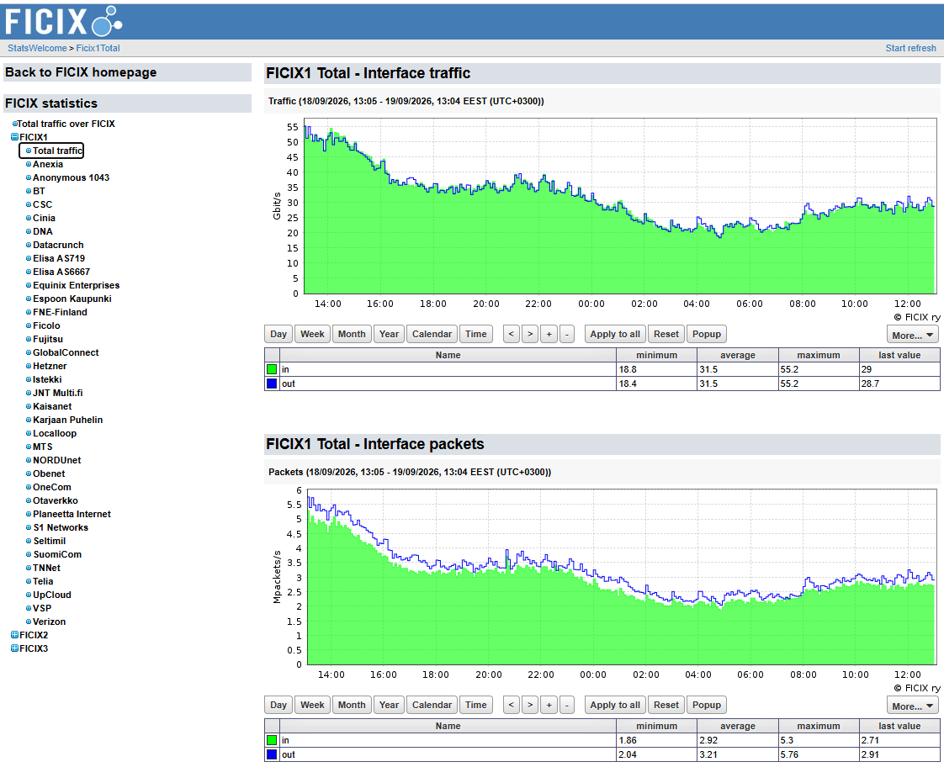
Based on the FICIX1 traffic graph for the period 18 September 2026, 13:05 to 19 September 2026, 13:04 EEST, the quietest traffic period was around 04:00 in the morning. At that time, the traffic level was at its lowest, at approximately 19–21 Gbit/s.

  - Which organisations or companies are connected to Ficix 3?
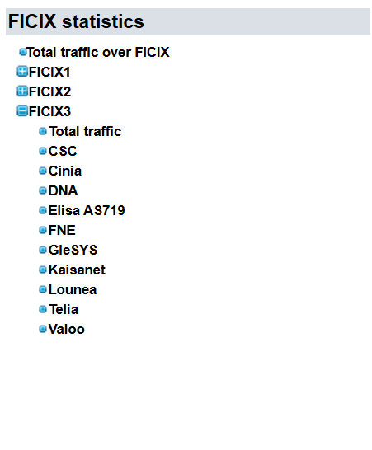
According to the FICIX3 statistics page, the organisations or networks connected to FICIX3 are:
• CSC
• Cinia
• DNA
• Elisa AS719
• FNE
• GleSYS
• Kaisanet
• Lounea
• Telia
• Valoo

- List all private IPv4 networks (RFC1918)
RFC 1918 defines three private IPv4 address ranges:
• 10.0.0.0/8
Range: 10.0.0.0 – 10.255.255.255
• 172.16.0.0/12
Range: 172.16.0.0 – 172.31.255.255
• 192.168.0.0/16
Range: 192.168.0.0 – 192.168.255.255

These addresses are used inside private networks and are not routed directly on the public Internet.

- What is the purpose of IPv4 private networks?
The purpose of IPv4 private networks is to allow devices inside homes, offices and organisations to communicate without using a public IPv4 address for every device. Private addresses can be reused in many different networks, which helps conserve the limited public IPv4 address space. When private devices need Internet access, a router normally uses Network Address Translation (NAT) to translate the private address into a public address. Private addressing also makes internal network design easier, although it does not provide security by itself.

- List and explain three or more purposes and features of the ICMP and or ICMPv6 protocol
ICMP (Internet Control Message Protocol) and ICMPv6 are mainly used for network control, error reporting and troubleshooting.

i. Error reporting:
ICMP can inform the sender when a packet cannot reach its destination. For example, a router may return a "Destination Unreachable" message if it cannot forward the packet.

ii. Network diagnostics:
Tools such as ping use ICMP Echo Request and Echo Reply messages to test whether another device is reachable and to measure response time.

iii. Route tracing:
Traceroute uses ICMP-related responses, such as "Time Exceeded", to identify the routers or hops between the source and destination.

iv. Path MTU information:
ICMP can help devices discover when a packet is too large for a network path. This allows the sender to reduce the packet size and avoid unnecessary fragmentation.

v. IPv6 neighbour and router functions:
ICMPv6 is especially important in IPv6 because it supports functions such as Neighbor Discovery, Router Advertisement and address configuration.

Blocking all ICMP or ICMPv6 traffic can cause network problems because some important diagnostic and control functions depend on these protocols.

- Try to solve these basic IP subnet calculations without checking the solutions:
  - If network address is 192.168.100.0, and subnet mask is 255.255.255.224, what is the broadcast address of the network?
The subnet mask 255.255.255.224 is /27, which gives a block size of 32 addresses.
The network starts at 192.168.100.0 and ends at 192.168.100.31.
Therefore, the broadcast address is:
192.168.100.31

  - If network address is 1.2.3.4, and broadcast address is 1.2.3.7, what is the subnet mask of the network?
The network address is 1.2.3.4 and the broadcast address is 1.2.3.7.
This subnet contains 4 addresses:
1.2.3.4
1.2.3.5
1.2.3.6
1.2.3.7
A block of 4 addresses corresponds to a /30 subnet.
The subnet mask for /30 is: 255.255.255.252

Therefore, the subnet mask is: 255.255.255.252 (/30)

  - If broadcast address is 192.168.129.255 and network mask is 255.255.254.0, what is the network address of the network?
The subnet mask is 255.255.254.0. The third octet is 254, so the block size is:
256 - 254 = 2

This means the subnet ranges increase by 2 in the third octet.

The broadcast address 192.168.129.255 belongs to the subnet range:
192.168.128.0 – 192.168.129.255

Therefore, the network address is: 192.168.128.0

- Try to solve these IP subnetting assignments without checking the solutions and document at least some examples/answers to the learning diary. Answers should contain (for each subnet): Network address, broadcast address and subnet mask:
  - Subnetting task 1:
    - The address space available is 172.16.64.0/23. Subnet it and create 5 (A, B, C, D and E) IPv4 subnets with following amount of hosts in each network: A = 85, B = 45, C = 95, D = 57, E = 34.
Step 1: Determine the required subnet size for each network.

The available address space is 172.16.64.0/23.

We should allocate the largest networks first and choose the smallest subnet that can support the required number of hosts.

C = 95 hosts
/25 gives 126 usable host addresses, so C needs /25.

A = 85 hosts
/25 gives 126 usable host addresses, so A needs /25.

D = 57 hosts
/26 gives 62 usable host addresses, so D needs /26.

B = 45 hosts
/26 gives 62 usable host addresses, so B needs /26.

E = 34 hosts
/27 gives only 30 usable addresses, which is not enough. Therefore, E also needs /26, which provides 62 usable host addresses.

Required subnet sizes:

C = /25
A = /25
D = /26
B = /26
E = /26

    - Leave some small amount of free addresses to each subnet. Avoid unnecessary waste of IPs.
To avoid unnecessary waste of IP addresses, each network should use the smallest subnet that can support the required number of hosts.
C needs 95 hosts, so /25 is required because it provides 126 usable host addresses.

A needs 85 hosts, so /25 is also required.
D needs 57 hosts, so /26 is suitable because it provides 62 usable host addresses.
B needs 45 hosts, so /26 is suitable.
E needs 34 hosts. A /27 provides only 30 usable host addresses, so /26 is required.

Therefore, the subnet sizes are:

C = /25
A = /25
D = /26
B = /26
E = /26

These are the smallest possible subnet sizes that meet the host requirements, so unnecessary IP address waste is avoided.
  - Subnetting task 2:
    - Same as task 1, but available address space is now 192.168.0.0/25 and networks/hosts are: A = 28, B = 10, C = 60, D = 4.
The available address space is 192.168.0.0/25.
To avoid unnecessary waste, I selected the smallest subnet that can support each required number of hosts.
C = 60 hosts /26 provides 62 usable host addresses, so C needs /26.
A = 28 hosts /27 provides 30 usable host addresses, so A needs /27.
B = 10 hosts /28 provides 14 usable host addresses, so B needs /28.
D = 4 hosts /29 provides 6 usable host addresses, so D needs /29.
Required subnet sizes: C = /26 A = /27 B = /28 D = /29
    - Leave some small amount of free addresses to each subnet. Avoid unnecessary waste of IPs.
Allocate subnet C first because it needs the largest number of hosts.
C needs 60 hosts, so I use a /26 subnet.
Network address: 192.168.0.0
Broadcast address: 192.168.0.63
Subnet mask: 255.255.255.192
Usable host range: 192.168.0.1 – 192.168.0.62

A /26 subnet provides 62 usable host addresses, which is enough for 60 hosts while avoiding unnecessary waste.
  - Subnetting task 3:
    - IPv6 address space available: 2001:708:510::/48. Create four /64 IPv6 networks.
The available IPv6 address space is: 2001:708:510::/48
To create /64 networks, the fourth hexadecimal block can be used as the subnet identifier.
Four /64 networks are:

1. 2001:708:510:0::/64
2. 2001:708:510:1::/64
3. 2001:708:510:2::/64
4. 2001:708:510:3::/64

IPv6 does not use broadcast addresses, so each subnet is identified by its /64 network prefix.
- Answer these questions:
  - Explain shortly the purpose of TCP acknowledgment and sequence numbers
TCP sequence numbers identify the position of data bytes in a TCP connection. Acknowledgment numbers tell the sender which data has been received successfully, and which byte is expected next. Together, they help TCP provide reliable and correctly ordered data delivery.
  - What is the purpose of TCP SYN bit?
The TCP SYN bit is used to start a TCP connection and synchronize sequence numbers between two devices. It is used during the TCP three-way handshake when a client and server establish a connection.
  - What is the purpose of TCP reset bit?
The TCP RST (reset) bit is used to immediately terminate or reject a TCP connection. For example, a device may send an RST packet when a connection request is made to a port where no service is listening.
  - When TCP retransmissions occur?
TCP retransmissions occur when the sender believes that some data has been lost. This can happen when an acknowledgment is not received within the expected time or when duplicate acknowledgments indicate that a segment is missing. The sender then retransmits the missing data.
  - What is flow-control? (for IP family protocols such as TCP)
Flow control prevents a fast sender from sending more data than the receiving device can process or store. TCP uses a receive window to inform the sender how much data the receiver can currently accept.
  - Explain TCP connection state LISTENING
The LISTENING state means that a TCP service is waiting for incoming connection requests on a specific TCP port. For example, an SSH server may listen on TCP port 22 and wait for clients to connect.
  - Explain TCP connection state ESTABLISHED
The ESTABLISHED state means that the TCP connection has been successfully created and both devices can send and receive data. This state is reached after the TCP three-way handshake has been completed.
  - What is the purpose of TCP or UDP source port?
The source port identifies the application or process that sent the data from the source device. It also helps the receiving device send the response back to the correct application. Client applications usually use temporary or dynamic source ports.
  - What is the purpose of TCP or UDP destination port?
The destination port identifies the application or network service that should receive the data on the destination device. For example, HTTPS normally uses destination TCP port 443.
  - What are the common well-known network service names for these TCP ports: 22, 23, 25, 80, 443, 3306?
TCP port 22 = SSH (Secure Shell)
TCP port 23 = Telnet
TCP port 25 = SMTP (Simple Mail Transfer Protocol)
TCP port 80 = HTTP (Hypertext Transfer Protocol)
TCP port 443 = HTTPS (HTTP Secure)
TCP port 3306 = MySQL database service
  - What are common connection-oriented protocol features/advantages, and why TCP is such protocol?
Connection-oriented protocols establish a connection before transferring application data. Their common features include reliable delivery, acknowledgments, retransmissions, correct data ordering, flow control and error detection. TCP is connection-oriented because it first establishes a connection using the three-way handshake and then maintains information about the connection while data is transferred.
  - What are connectionless protocols features (or lack of), and why UDP is connectionless protocol?
A connectionless protocol sends data without first establishing a connection between the sender and receiver. It does not normally provide acknowledgments, retransmissions, guaranteed delivery, correct packet ordering or flow control.

UDP is connectionless because each UDP datagram is sent independently without creating and maintaining a connection between the two devices.
  - Why most services using UDP prefer max 512 byte UDP datagrams?
Small UDP datagrams reduce the risk of IP fragmentation and are easier to transmit across networks with different MTU sizes. If a UDP datagram is fragmented and one fragment is lost, the complete datagram may have to be sent again by the application.The 512-byte size is especially associated with the historical DNS UDP message limit. It is not a general maximum requirement for all UDP applications.
  - When it is more reasonable to use UDP instead of TCP?
UDP is more suitable when low delay and low protocol overhead are more important than guaranteed delivery. It is useful when occasional packet loss is acceptable or when the application handles reliability itself. Examples include real-time voice and video, online games, DNS queries and some IoT communication.
  - What is the length of TCP header without extra options? What about UDP header?
A TCP header without additional options is 20 bytes long.
A UDP header is 8 bytes long.
UDP therefore has less protocol overhead than TCP.

  - What is TCP Nagle’s algorithm? When it should be disabled for networking applications?
Nagle's algorithm reduces the number of small TCP packets sent over a network. It combines small amounts of data and waits before sending them when previous data has not yet been acknowledged. This can improve network efficiency.
It may be disabled in applications where very low latency is more important than reducing the number of packets, such as some real-time applications, interactive games or other highly responsive communication systems.
  - What is Maximum Transmission Unit (MTU) and IPv4 fragmentation?
The Maximum Transmission Unit (MTU) is the largest packet size that can be transmitted over a network link without needing fragmentation. A common Ethernet MTU is 1500 bytes.
IPv4 fragmentation can occur when an IP packet is larger than the MTU of a link along its path. The packet may be divided into smaller fragments, which are reassembled at the destination. Fragmentation should normally be avoided because it adds overhead and can reduce reliability and performance.
  - What is a raw socket?
A raw socket allows an application to access and create network packets at a lower level than normal TCP or UDP sockets. It can give the application direct access to IP packets and protocol headers.
Raw sockets are commonly used for network diagnostic tools, protocol testing and packet-generation applications. They usually require elevated operating-system privileges.
  - What is port forwading?
Port forwarding is a router or firewall configuration that redirects incoming traffic from a specific IP address and port to another device and port inside a private network.
For example, traffic arriving at a router's public IP address on a selected port can be forwarded to a web server inside the local network. Port forwarding is commonly used together with NAT.
- Describe these protocols or services shortly:
  - IPSec
IPSec (Internet Protocol Security) is a group of protocols used to protect IP communication. It can encrypt data, check data integrity and authenticate devices. IPSec is commonly used in VPN connections.
  - RTP and RTCP
RTP (Real-time Transport Protocol) is used to carry real-time audio and video over IP networks.
RTCP (Real-time Transport Control Protocol) works together with RTP. It provides information about transmission quality, such as packet loss, delay and timing.
  - QUIC (IETF)
QUIC is a modern transport protocol standardized by the IETF. It runs over UDP and includes security using TLS. QUIC is designed to reduce connection delay and improve performance, especially for web traffic such as HTTP/3.
  - Wireguard
WireGuard is a modern VPN protocol. It is designed to be simple, fast and secure. It uses strong cryptography and is commonly used to create encrypted VPN tunnels between devices or networks.
  - DoH
DoH means DNS over HTTPS. It sends DNS queries through an encrypted HTTPS connection. This helps protect DNS traffic from being easily viewed or modified by other parties on the network.
  - Round-robin DNS
Round-robin DNS is a simple load distribution method. One domain name can have several IP addresses, and the DNS server can return them in a rotating order. This can help distribute traffic between several servers.
  - LDAP
LDAP (Lightweight Directory Access Protocol) is used to access and manage directory information over a network. It is commonly used for user accounts, authentication and organisational information.
  - Radius
RADIUS (Remote Authentication Dial-In User Service) is used for authentication, authorisation and accounting. It is commonly used in Wi-Fi networks, VPNs and other network access systems.
  - Syslog
Syslog is a standard used to send and store system and network log messages. Routers, servers, switches and other devices can send their logs to a central Syslog server for monitoring and troubleshooting.
  - NTP
NTP (Network Time Protocol) is used to synchronize the clocks of computers and network devices. Accurate time is important for logs, security systems and communication between systems.
  - SNMP
SNMP (Simple Network Management Protocol) is used to monitor and manage network devices. It can collect information such as device status, traffic levels, errors and system performance.
  - SMTP
SMTP (Simple Mail Transfer Protocol) is used to send email messages between mail servers and from email clients to mail servers. It is mainly used for outgoing email communication.
  - SMB/CIFS
SMB (Server Message Block) is a protocol used for sharing files, printers and other network resources. CIFS is an older version of SMB. It is commonly used in Windows-based networks.
- When listing services with netstat command, what is the meaning if some network service is LISTENING and binded to the IP address 127.0.0.1? What if the service is LISTENING IP address 0.0.0.0?
If a service is LISTENING on 127.0.0.1, it is bound to the loopback interface. This means that only applications running on the same computer can normally connect to that service. Other computers on the network cannot access it directly.
If a service is LISTENING on 0.0.0.0, it is listening on all available IPv4 network interfaces of the computer. Therefore, the service may accept connections through any of the computer's IPv4 addresses, depending on firewall rules and other security settings.
- Why some applications are using or offer “keepalive” mechanism to maintain established connection (for example SSH connections)?
A keepalive mechanism is used to check whether an established connection is still active. It sends small periodic messages when the connection is idle.
This is useful because some routers, firewalls or NAT devices may remove inactive connections after a certain time. Keepalive messages can help prevent this from happening.
Keepalive can also help detect when the remote device or network connection has failed, so the application can close the broken connection instead of waiting for a long time.

- Study available options with command line command “netstat /?” (Windows) or netstat –help (Linux, maybe MacOS). What different things you can check with netstat command?
The netstat command can be used to check different types of network information on a computer.
It can show:

- Active TCP connections
- TCP and UDP ports that are listening
- Local and remote IP addresses and port numbers
- The current state of TCP connections, such as LISTENING and ESTABLISHED
- Network protocol statistics
- The routing table
- Network interface statistics
- Process IDs associated with network connections
- Executable programs related to connections, depending on the operating system and permissions

Netstat is useful for troubleshooting network connections, checking open ports and identifying which applications are using network services.
- Do the 50 ms mystery quiz from https://mysteries.wizardzines.com/. What was the cause of extra 50 ms delay?
The extra delay was caused by the interaction between TCP Nagle’s algorithm on the client and delayed acknowledgments (ACKs) on the server.
The client sent the HTTP POST request in two small parts. After sending the first part, Nagle’s algorithm waited for an ACK before sending the next part. At the same time, the server used delayed ACK and waited for about 40 ms before sending the acknowledgment.
Therefore, both sides were waiting, which created the extra delay of around 50 ms. Disabling Nagle’s algorithm with TCP_NODELAY, or avoiding splitting the POST request into separate small packets, can solve the problem.

- Use Croc to move file or files between two or more hosts/devices. Answer shortly:
  - How the Croc works?
Croc is a command-line file transfer tool that allows two computers to send files and folders securely.
The sender runs a command such as: croc send filename
Croc then creates a short code phrase. The receiver enters this code phrase on the other computer to start the transfer.

Croc uses password-authenticated key agreement (PAKE) to create an encryption key, so the file transfer is protected with end-to-end encryption. It can also resume interrupted transfers.

  - How the Croc moves files if both hosts are not directly visible to each other? (for example, both are behind NATs or basic firewalls)
If both computers are behind NATs or basic firewalls and cannot connect directly, Croc uses a relay server.
Both computers create outgoing connections to the relay server. The relay forwards the encrypted data between the sender and receiver.
The file contents remain end-to-end encrypted, so the relay server does not need to read the original files. This allows Croc to work without configuring port forwarding on the routers.
- Study how NTP protocol operates and analyse this Python NTP client code. Also available here as plain text.
  - This Python script uses direct socket programming to access the NTP server. Comment individual socket programming related code lines. Also, answer these:
    - What is the NTP server (DNS) hostname? pool.ntp.org
    - What is the destination port number being used?
The destination port number used by the NTP client is: 123

    - Is this Python script using TCP or UDP? How do you know?
The Python script is using UDP.
I know this because the socket is created with SOCK_DGRAM: socket(AF_INET, SOCK_DGRAM)
SOCK_DGRAM means that the program is using a UDP datagram socket.
  - Try to execute the app with Python
I executed the NTP client with Python using the command:
python .\ntp_client.py
The program successfully contacted the NTP server and returned:
Sat Sep 19 20:28:18 2026
This confirms that the UDP-based NTP client worked correctly and received time information from the NTP server.
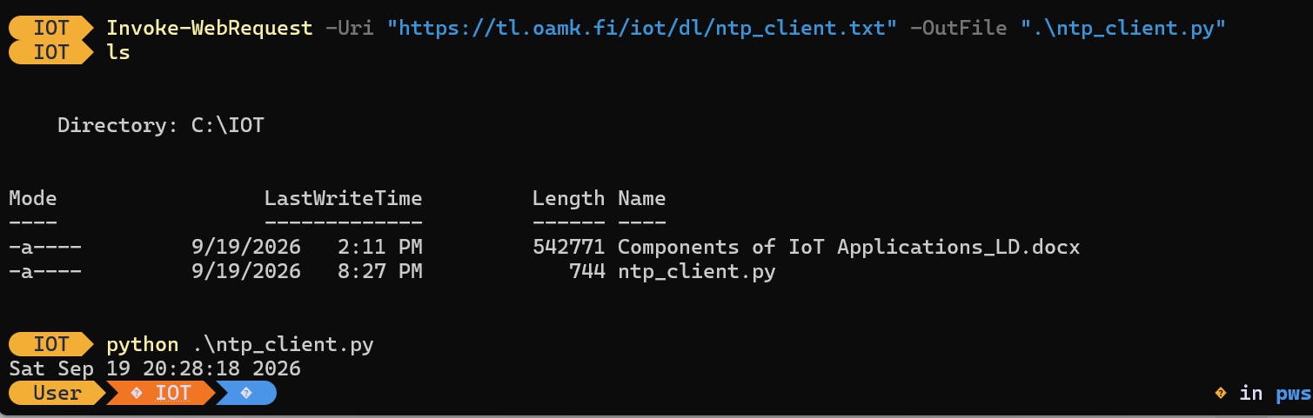
- Do these Python programming assignments with Windows or Linux (or with MacOS if you want and know how)
  - For example, use https://realpython.com/python-sockets/ or similar site(s) for socket programming example codes and create TCP client and TCP server Python scripts
I created and tested a simple TCP client and TCP server using Python socket programming.
The server was running on: 127.0.0.1:65432
The client connected successfully and sent: “Hello from TCP client”
The server received the message and replied: “Hello from TCP server”
The test confirmed that the TCP connection was successfully established and that data could be sent in both directions between the client and server.

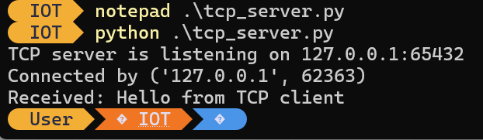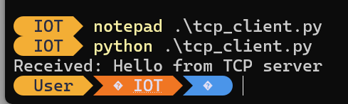

  - Establish a TCP connection between your client and server Python scripts (either as localhost traffic or between two separate hosts if you have access to two or more Python running hosts without firewall preventing the traffic)
I established a TCP connection between my Python client and server using localhost.
The TCP server was listening on: 127.0.0.1:65432
The client successfully connected to the server and sent the message:
Hello from TCP client
The server received the message and replied:
Hello from TCP server
The successful connection and message exchange confirmed that the TCP client and server were working correctly.

  - Transfer some ASCII text strings between the hosts
    - TCP client connects to the server, sends some plain text string and then disconnects
I used my Python TCP client to connect to the TCP server through localhost at 127.0.0.1:65432.
The client sent the ASCII text string: "Hello from TCP client"
After sending the message and receiving the server response, the client socket was closed automatically when the program finished.

    - Server prints the text to the console or elsewhere
The TCP server received the text string sent by the client and printed it to the console.
The server displayed:
Received: Hello from TCP client
This confirmed that the server successfully received and processed the ASCII text sent by the client.
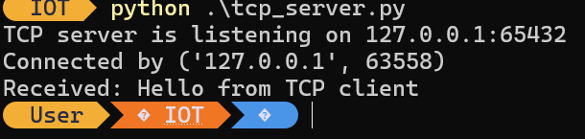
    - Save your source codes and work. You need scripts again during the course week #5 (Wireshark protocol analyzer assignments)
  - Use netstat or similar command line tools to check the TCP connection status (for example the Python server script LISTENING the selected TCP port)
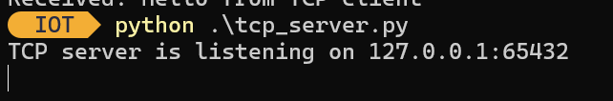
I used the netstat command to check the TCP server connection status:
netstat -ano | findstr :65432

The output showed: TCP 127.0.0.1:65432 0.0.0.0:0 LISTENING 2464

This confirms that the Python TCP server was listening on local IP address 127.0.0.1 and TCP port 65432.

The LISTENING state means that the server was waiting for an incoming TCP connection. The number 2464 is the process ID (PID) of the program using this port.

- Define following terms and concepts shortly:
  - What is the difference between encoding and encryption?
Encoding changes data into another format so that it can be stored, transmitted, or processed correctly. It is not designed to keep the data secret, and normally anyone who knows the encoding method can decode it. Examples include Base64 and UTF-8.Encryption changes data into an unreadable form to protect its confidentiality. A correct key is normally required to decrypt the data and read the original information. Examples include AES and RSA.In short, encoding is mainly for data representation and compatibility, while encryption is mainly for security and confidentiality.
  - List few common encryption algorithms or systems
Some common encryption algorithms and systems are,

• AES (Advanced Encryption Standard) – a widely used symmetric encryption algorithm for protecting data.
• RSA – an asymmetric encryption algorithm that uses a public key and a private key.
• ECC (Elliptic Curve Cryptography) – an asymmetric encryption system that provides strong security with smaller key sizes.
• DES and 3DES – older symmetric encryption algorithms that have mostly been replaced by stronger modern methods.
• Blowfish and Twofish – symmetric encryption algorithms designed for fast and secure data encryption.

Today, AES, RSA and ECC are among the most commonly used modern cryptographic methods.

  - List few common encoding systems
Some common encoding systems are:

• Base64 – converts binary data into text characters so that it can be transmitted or stored in text-based systems.
• ASCII – represents English letters, numbers and symbols using numeric codes.
• UTF-8 – a widely used character encoding that can represent text from many different languages.
• Hexadecimal encoding – represents binary data using hexadecimal values from 0–9 and A–F.
• URL encoding – converts special characters into a format that can be safely used in web addresses, for example a space can be represented as %20.

Encoding is mainly used to represent data in a suitable format. It does not normally provide confidentiality or security.
  - What are plain text protocols? List some
Encapsulation is the process of adding protocol information to data as it moves down through the network layers.
For example, application data can be encapsulated inside a TCP segment. The TCP segment is then encapsulated inside an IP packet, and the IP packet is finally encapsulated inside an Ethernet frame.
Each layer adds its own header, and sometimes a trailer, so that the data can be correctly delivered across the network.
In simple terms:

Application data → TCP segment → IP packet → Ethernet frame
  - Encapsulation (protocol)
Encapsulation is the process of adding protocol information to data as it moves down through the network layers.
For example, application data can be encapsulated inside a TCP segment. The TCP segment is then encapsulated inside an IP packet, and the IP packet is finally encapsulated inside an Ethernet frame.
Each layer adds its own header, and sometimes a trailer, so that the data can be correctly delivered across the network.
In simple terms:
Application data → TCP segment → IP packet → Ethernet frame

  - JSON, XML, YAML, CSV
JSON, XML, YAML and CSV are common data formats used to store and exchange information.

• JSON (JavaScript Object Notation) – a lightweight and human-readable format that is widely used in web APIs and applications. It stores data using key-value pairs and arrays.

• XML (Extensible Markup Language) – a structured, tag-based format that can represent complex hierarchical data. It is flexible but usually more verbose than JSON.

• YAML (YAML Ain’t Markup Language) – a human-friendly format that uses indentation to organize data. It is commonly used for configuration files.

• CSV (Comma-Separated Values) – a simple text format for storing tabular data. Each line normally represents a row, and values are separated by commas.

In summary, JSON, XML and YAML are suitable for structured data, while CSV is mainly used for simple table-like data.

- Install Wireshark protocol analyser and inspect your IP traffic (DNS requests, web browsing and such) with the Wireshark:
  - Analyse the plain text traffic between the TCP socket Python scripts you did during the course week #4. Note: use localhost network interface when capturing host internal traffic (localhost/127.0.0.1)
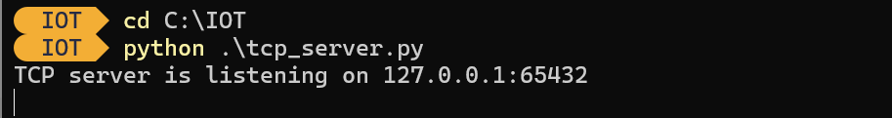
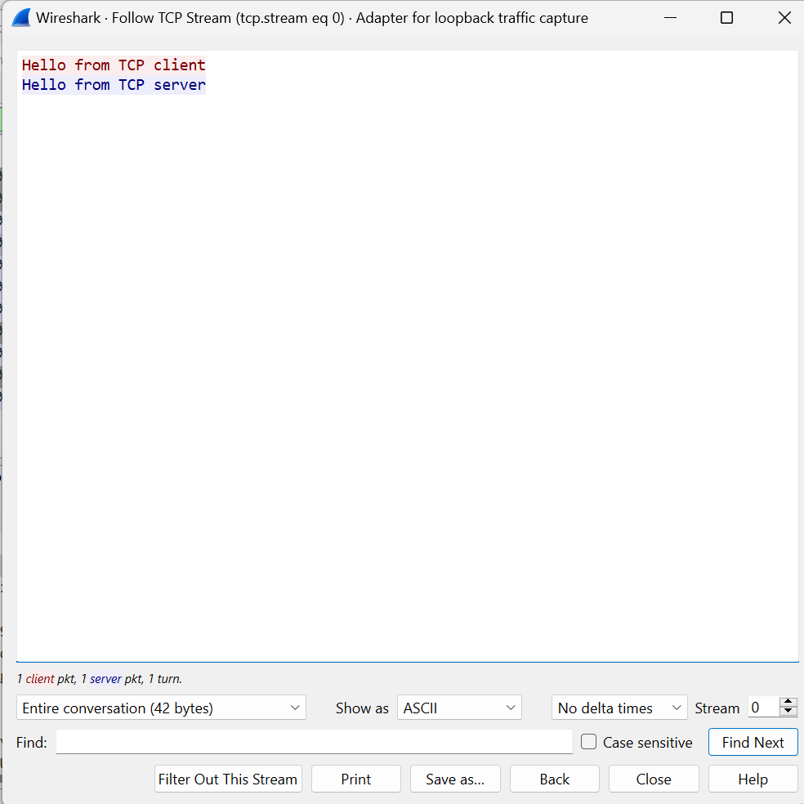
I analysed the traffic between my Python TCP client and server using Wireshark. Because both programs were running on the same computer and communicating through 127.0.0.1, I captured the traffic using the "Adapter for loopback traffic capture" interface.
I used the display filter tcp.port == 65432
Wireshark captured the TCP connection between the client and server. Using the "Follow TCP Stream" feature, I could clearly read the messages:
"Hello from TCP client"
"Hello from TCP server"
This shows that the application data was transmitted as plain text without encryption. Anyone who could capture this traffic could read the message contents directly.

  - Try to ping 8.8.8.8 from command prompt and capture the traffic. What protocols ping was using? What is the total header length of your ping request (all used protocol headers combined when ping sends echo request)?
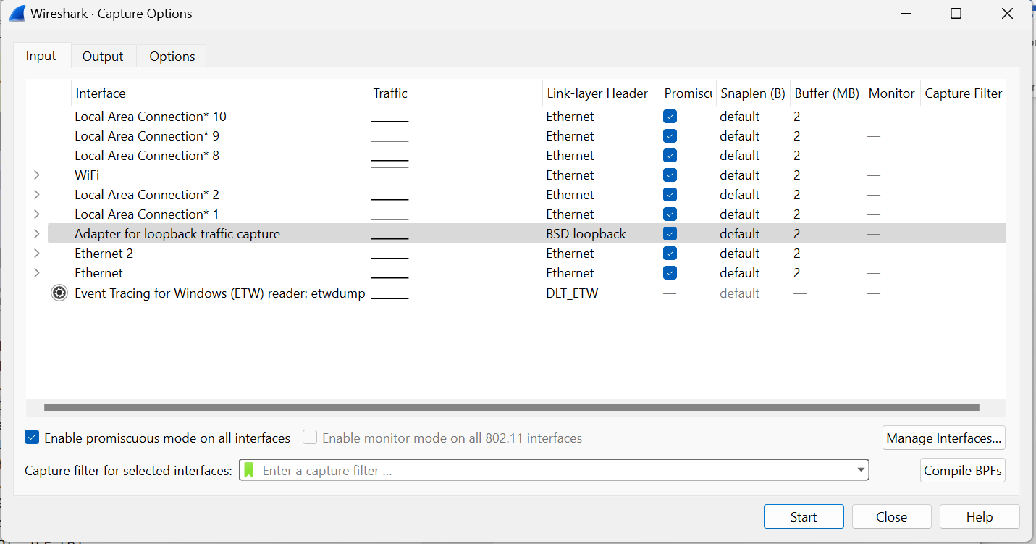
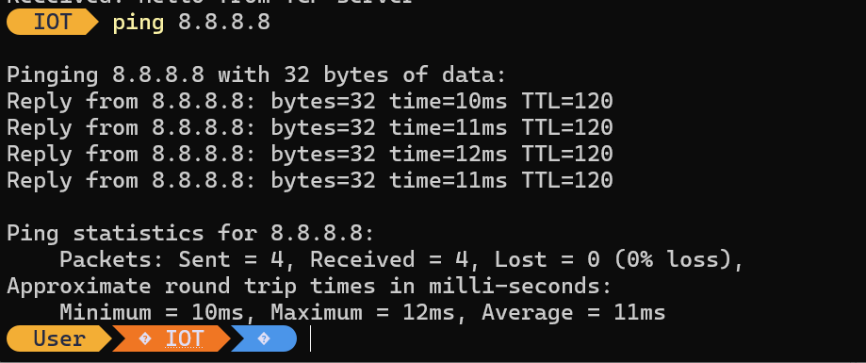
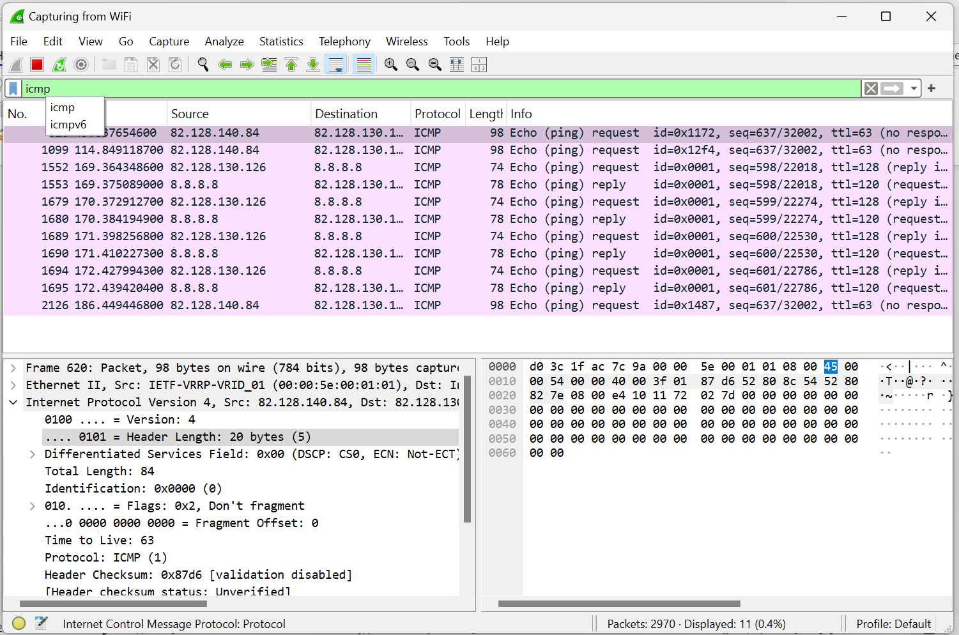
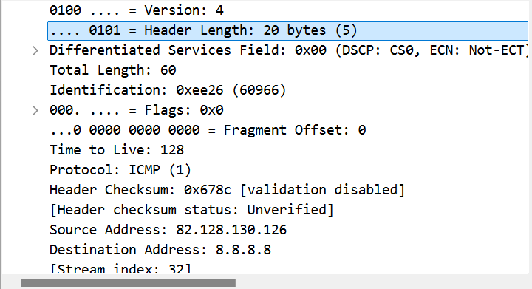
I used the Windows ping command to send packets to 8.8.8.8 and captured the traffic with Wireshark.
The ping request used ICMP (Internet Control Message Protocol) over IPv4.
From my Wireshark capture:
IPv4 header = 20 bytes
ICMP header = 8 bytes
Ping data = 32 bytes
Therefore, the IP + ICMP header length is:
20 + 8 = 28 bytes

Because the packet was captured on the Wi-Fi interface, Wireshark also showed an Ethernet II header of 14 bytes. If the Ethernet header is included, the total protocol header length on the captured frame is:
14 + 20 + 8 = 42 bytes

The complete captured frame was 74 bytes:
42 bytes of headers + 32 bytes of ping data = 74 bytes.

  - Capture some web browsing traffic and related DNS requests. What are those A (and maybe AAAA requests)? Which protocol is used for DNS requests? (Note: This cannot be done with web browser if your browser uses DNS over HTTPS. Most do now. Either skip this task or disable DoH temporary in the web browser settings)
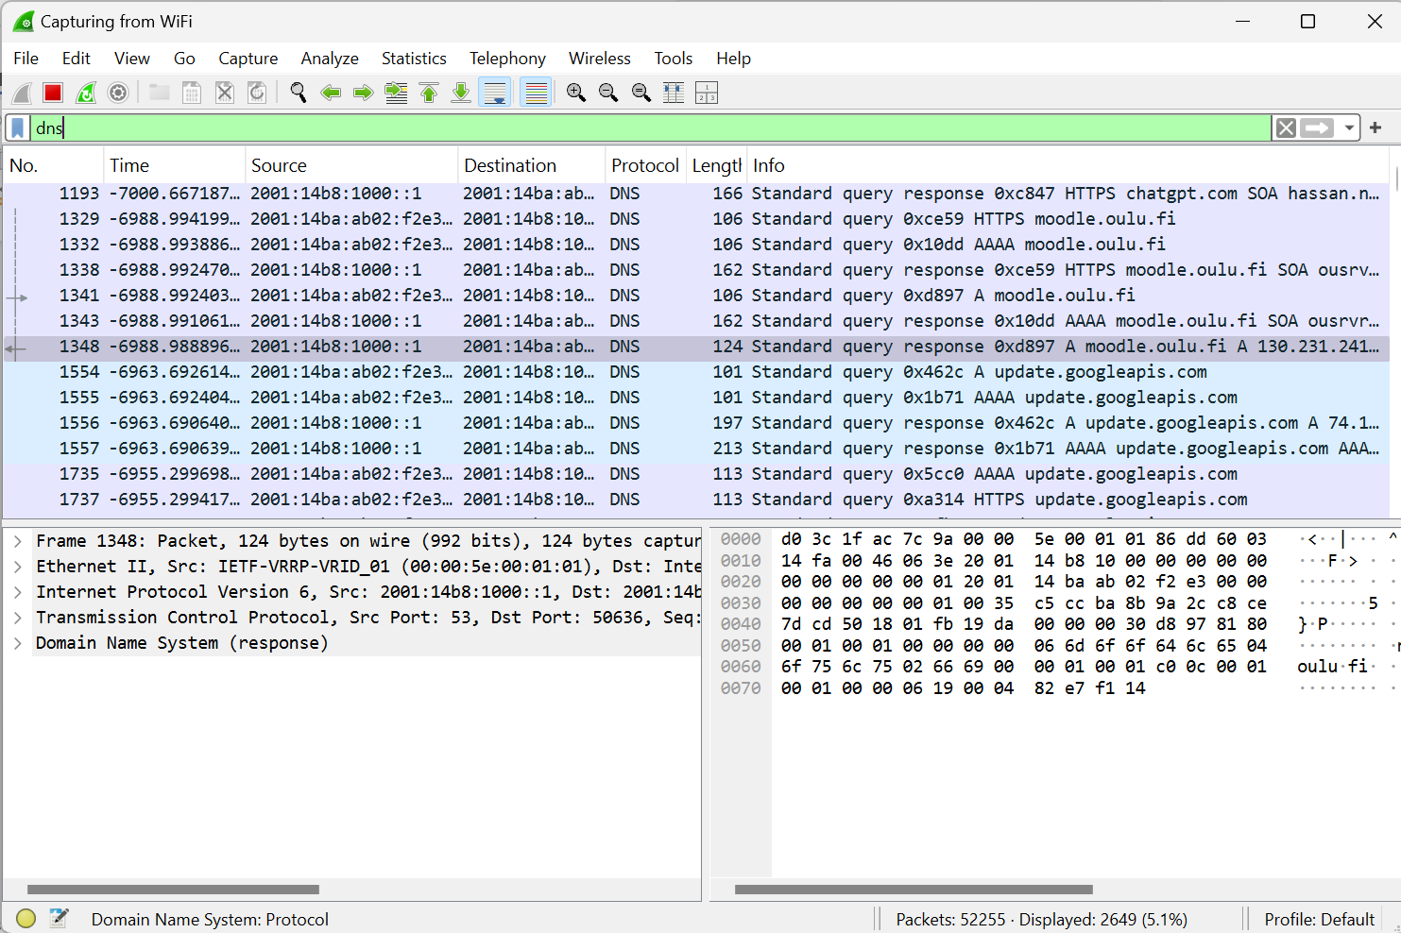
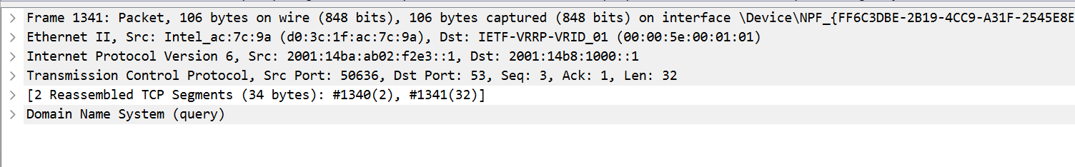
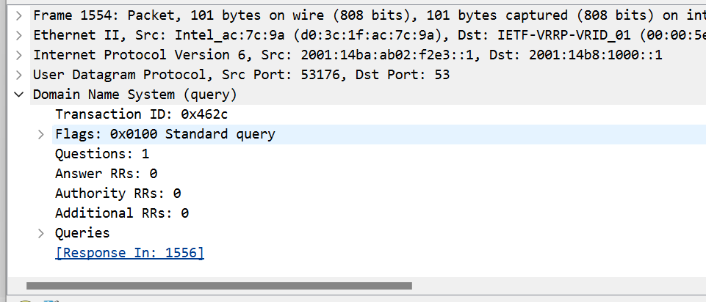
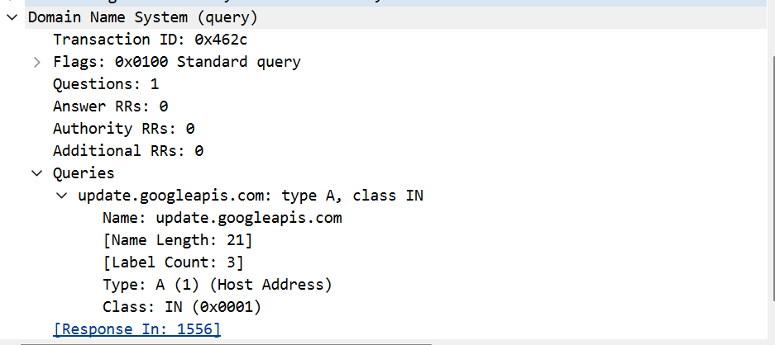
I captured web browsing and DNS traffic using Wireshark on the Wi-Fi interface.

An A record request asks the DNS server for the IPv4 address of a hostname. In my capture, for example, update.googleapis.com was requested with record type A.
An AAAA record request asks for the IPv6 address of a hostname. I also captured an AAAA request for update.googleapis.com.
In my capture, normal DNS queries mainly used UDP with destination port 53. Wireshark showed:
User Datagram Protocol
Destination Port: 53

I also observed that DNS can use TCP port 53 in some cases.

Therefore:
A record = IPv4 address request
AAAA record = IPv6 address request
DNS normally uses UDP port 53, but TCP port 53 can also be used.
- Download this zipper pcap traffic file and inspect it with Wireshark. The IP traffic sample is about IoT device sending base64 encoded and JSON formatted data to a server. Answer these questions:
  - What is the total size of captured frame in bits?
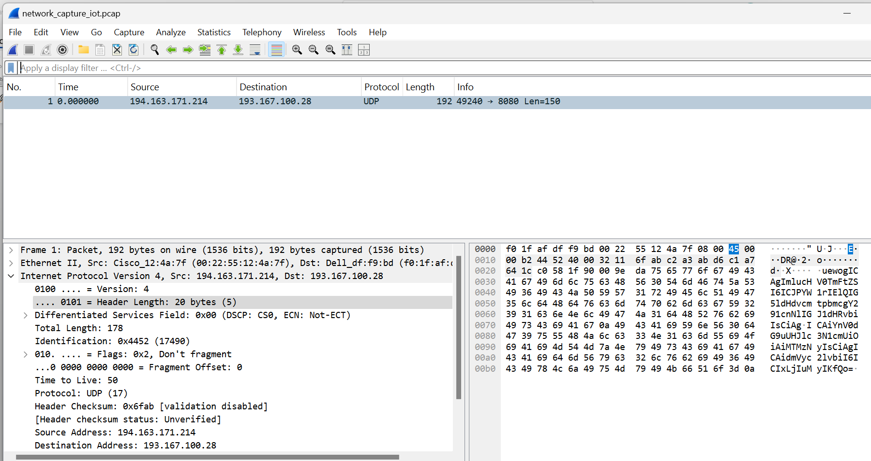
The total size of the captured frame is 1536 bits (192 bytes).

  - What is the payload length (data) in bytes?
IPv4 total length = 178 bytes
IPv4 header = 20 bytes
UDP header = 8 bytes

178 - 20 - 8 = 150 bytes
The payload length is 150 bytes.
  - What is the source IP address of device sending the traffic?
The source IP address of the device sending the traffic is 194.163.171.214.
  - What is the destination IP address receiving the traffic?
The destination IP address receiving the traffic is 193.167.100.28.
  - What is the IP family procotol delivering the data?
The protocol delivering the data is UDP (User Datagram Protocol). The packet is carried over IPv4.
  - What is the source port?
The source port is 49240.
  - What is the destination port?
The destination port is 8080.
  - Extract the payload as printable text (use right mouse button and copy as printable text for the data part only). Use any base64 decoder to convert the data to a plain text JSON message. What is the content of JSON formatted data?
    - Hint: If you struggle with this task, you can get the UDP payload if you select the UDP datagram with right mouse button in the Wireshark packet view, and use “Follow”. It gives you the UDP packet data payload as ASCII text you can copy-paste from the Wireshark popup window to any common base64 decoder
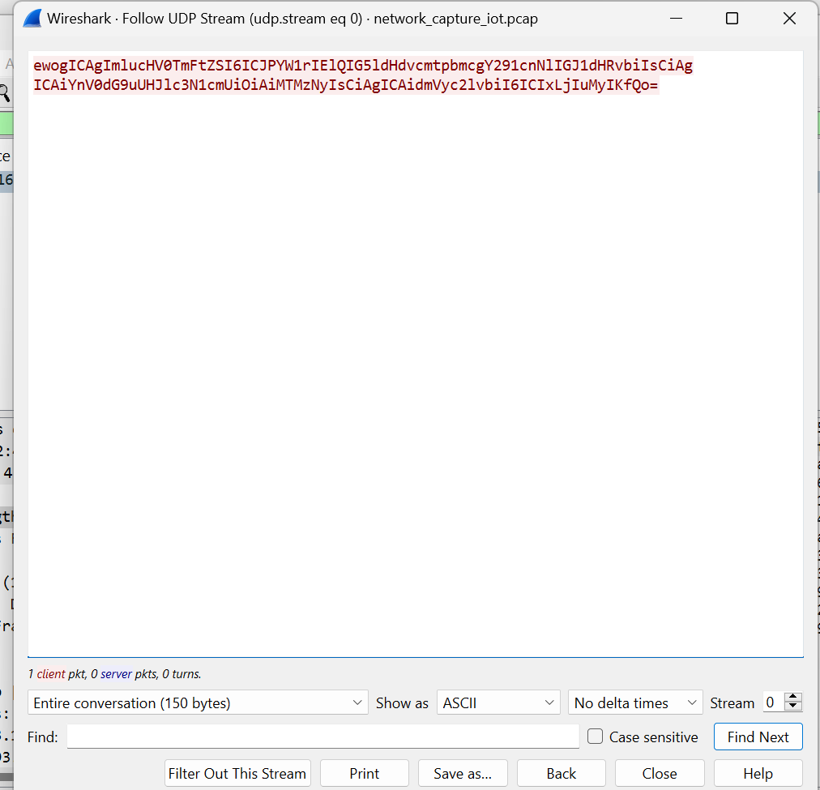
I opened the provided network_capture_iot.pcap file in Wireshark and inspected the captured packet.
The total size of the captured frame is 1536 bits, which is 192 bytes.
The UDP payload length is 150 bytes.
The source IP address of the IoT device is:
194.163.171.214
The destination IP address receiving the traffic is:
193.167.100.28

The IP family used to deliver the packet is IPv4. The transport protocol carrying the application data is UDP.
The source port is:
49240
The destination port is:
8080
I used Wireshark's "Follow UDP Stream" function to extract the data payload as printable text. The payload was Base64 encoded.
After decoding the Base64 data, the following JSON message was obtained:
{
"inputName": "Oamk IP networking course button",
"buttonPressure": "1337",
"version": "1.2.3"
}
This shows that the IoT device sent structured JSON data to the server, but the JSON content was first encoded using Base64.
- Download this zipper pcap traffic file and inspect it with Wireshark. Traffic is simple MySQL session example from Wireshark Wiki. Answer these questions:
  - What is the destination IP address receiving the traffic?
The destination IP address receiving the MySQL traffic is 192.168.0.254.
  - What is the destination TCP port?
The destination TCP port is 3306.
  - Use Wireshark's follow TCP stream feature (right mouse button) and inspect what are the two database rows (animals) and related values which were inserted to the foo table's animal and name columns?
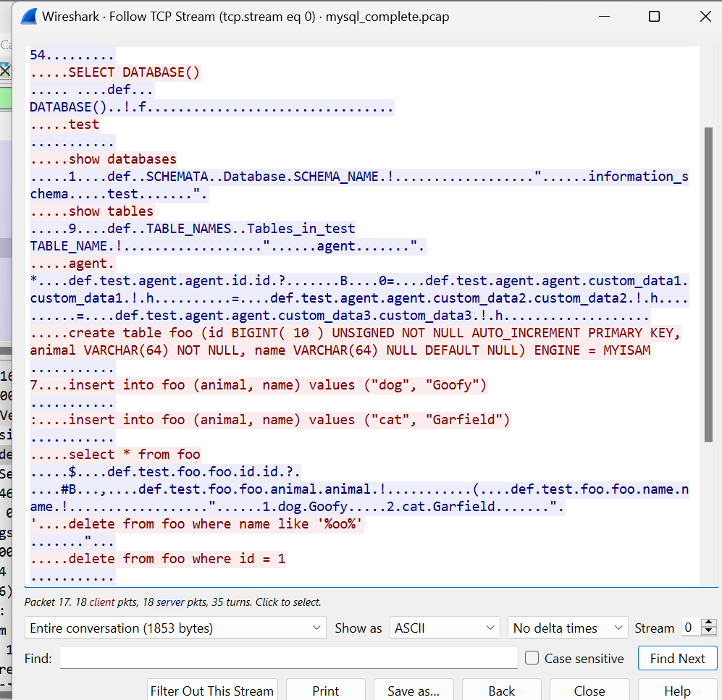
The two rows inserted into the foo table were:
1. animal = dog, name = Goofy
2. animal = cat, name = Garfield
I inspected the provided MySQL traffic capture in Wireshark.
The destination IP address receiving the traffic is: 192.168.0.254
The destination TCP port is: 3306
I then used Wireshark's "Follow TCP Stream" feature to inspect the MySQL session. The stream showed two INSERT statements for the foo table:
insert into foo (animal, name) values ("dog", "Goofy")
insert into foo (animal, name) values ("cat", "Garfield")
Therefore, the two inserted database rows were:

1. animal = dog, name = Goofy
2. animal = cat, name = Garfield
- Download this zipped pcap traffic file and inspect it with Wireshark. Traffic has been captured from host 192.168.80.32. Answer these questions:
  - What is the MAC address of host 192.168.80.32?
The MAC address of host 192.168.80.32 is 08:00:27:f1:90:ad
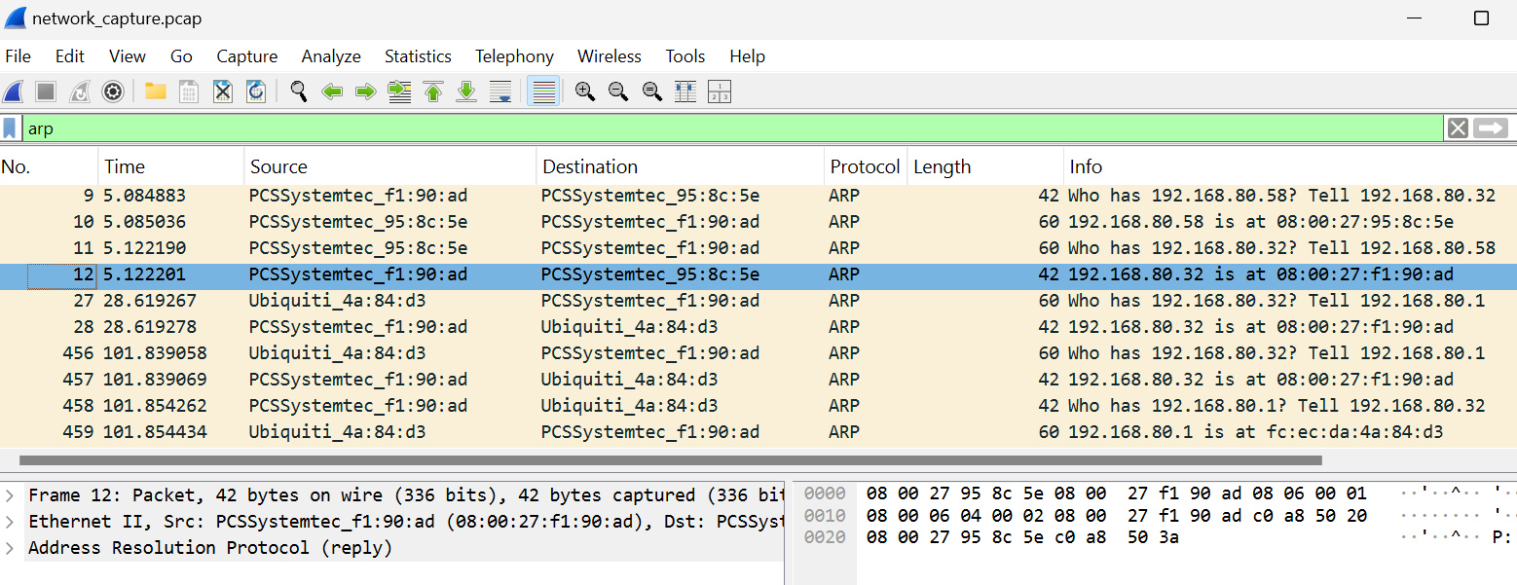
  - What is the MAC address of host 192.168.80.1? Which vendor has build the ethernet chipset of host 192.168.80.1? (use Wireshark or IEEE OUI data)
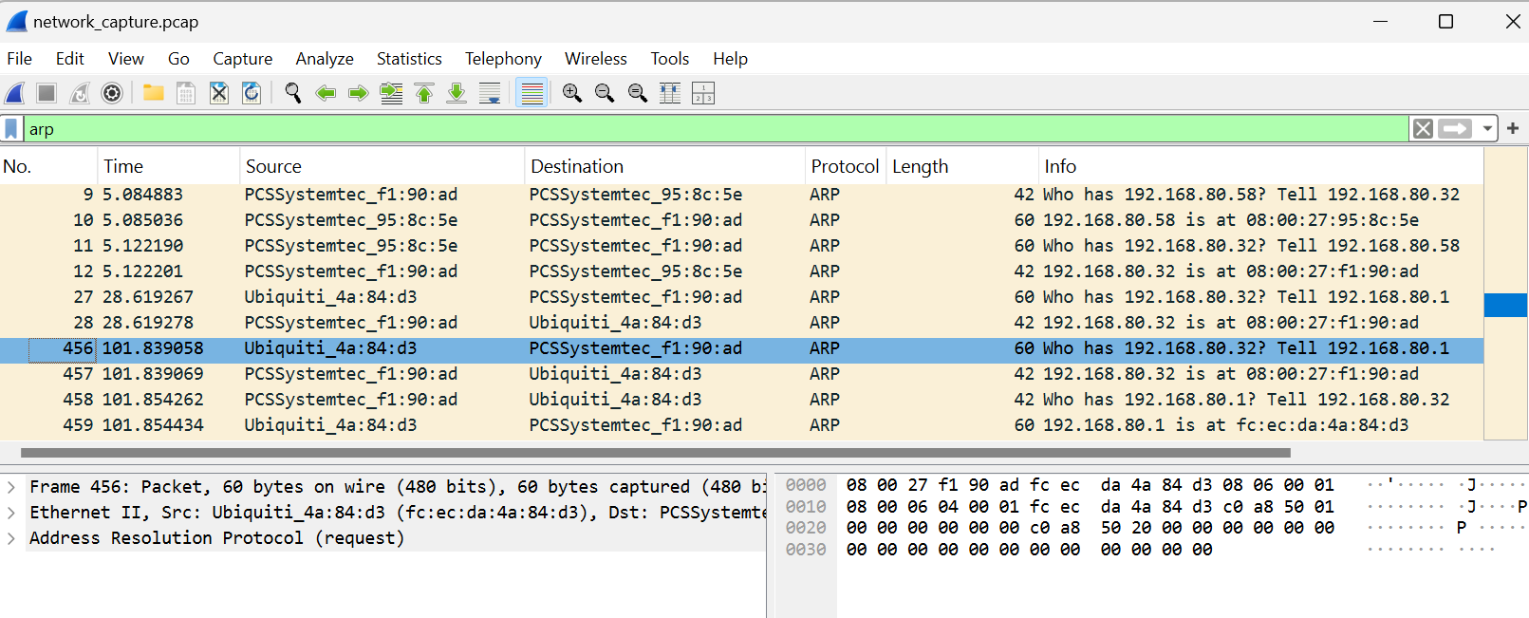
The MAC address of host 192.168.80.1 is fc:ec:da:4a:84:d3.
The vendor is Ubiquiti.
  - Which IP address sent ICMP echo requests to this (192.168.80.32) host? Also, there is a repeating short message inside ICMP datagrams the host sent as ICMP echo request payload. What is the repeated message?
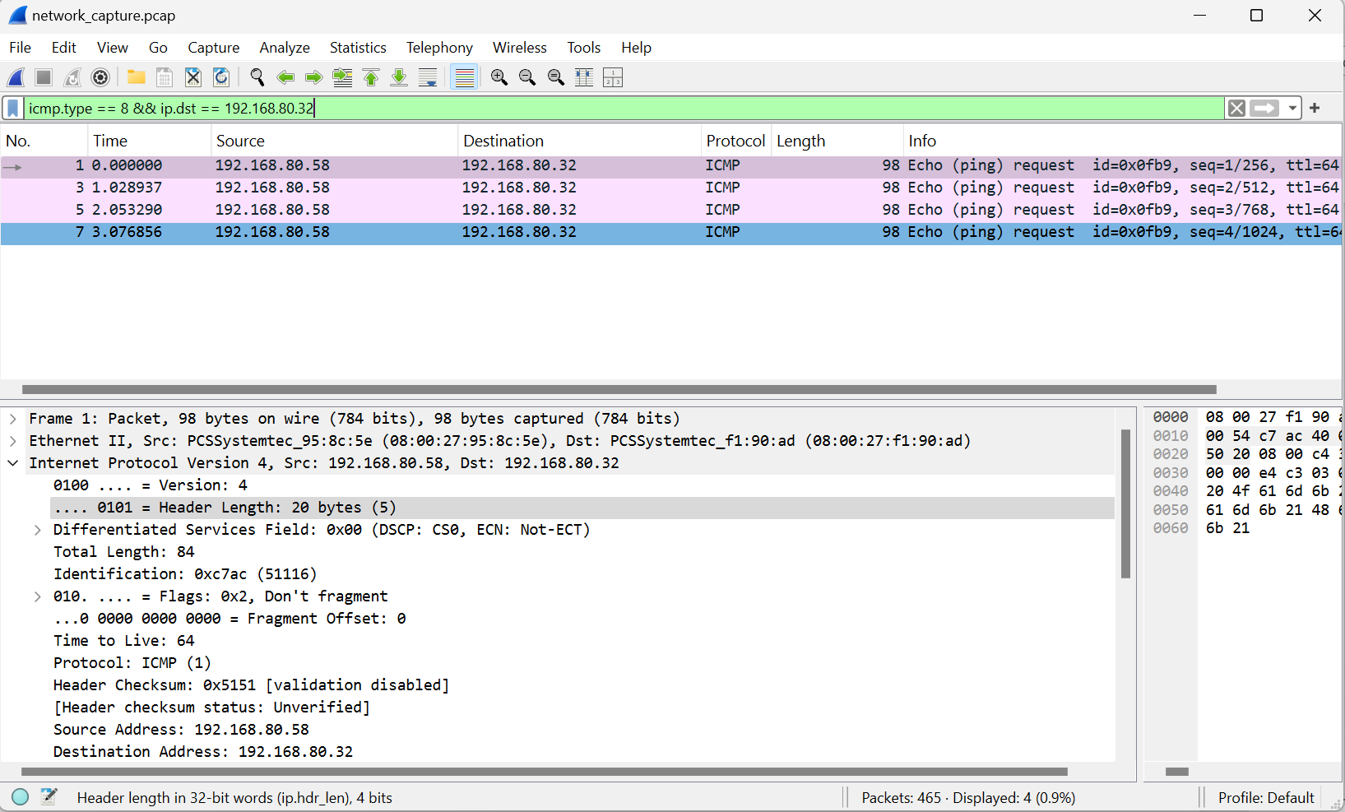
Source: 192.168.80.58
Destination: 192.168.80.32
Protocol: ICMP
Info: Echo (ping) request

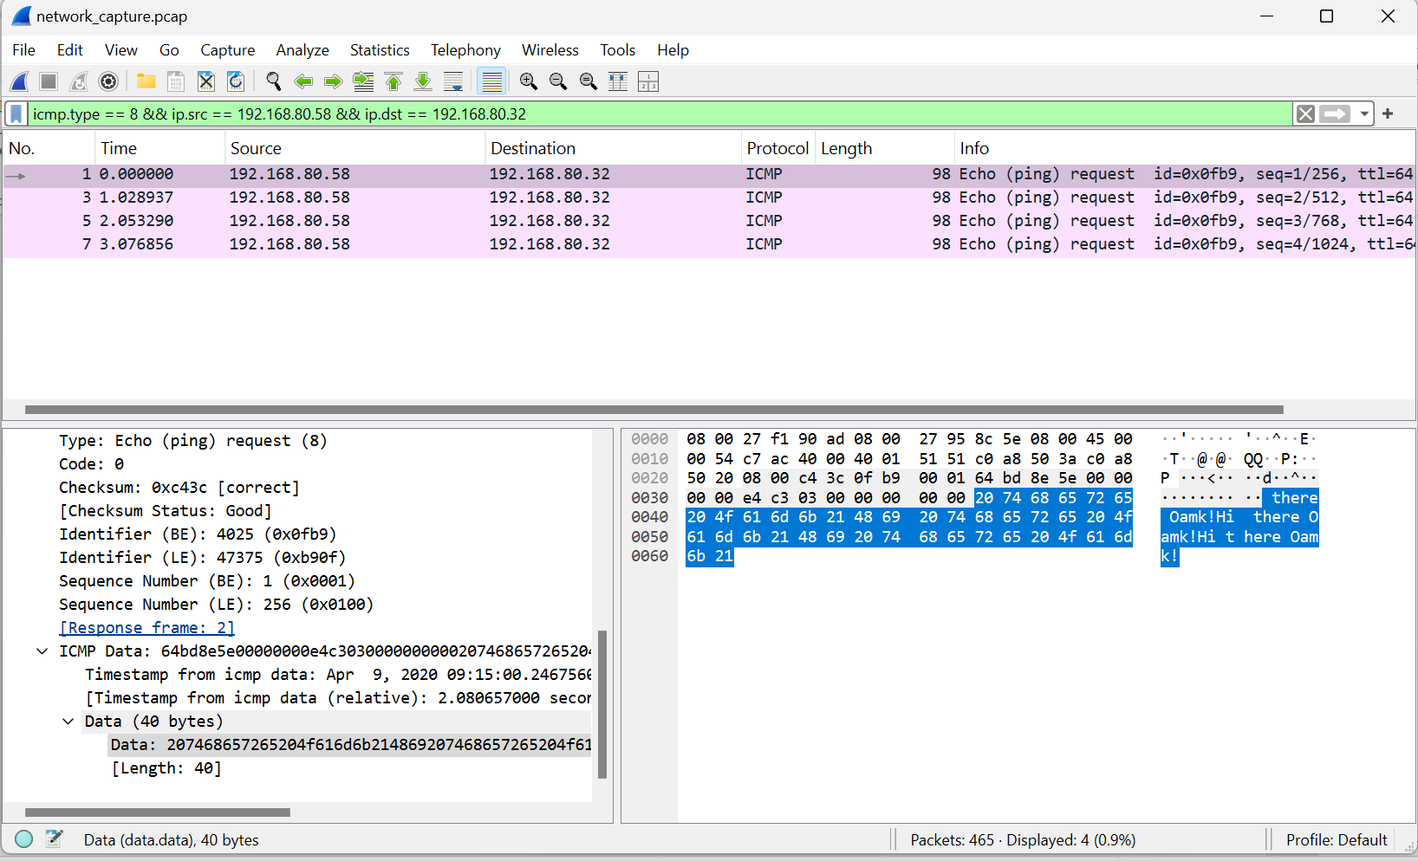

The IP address that sent ICMP Echo Requests to 192.168.80.32 was 192.168.80.58.
The repeated short message inside the ICMP Echo Request payload was:
"Hi there Oamk!"

  - What was the web page the host 192.168.80.32 visited first (full web page address, not just the host)? What was the web browser or HTTP user agent string used to access that web server?
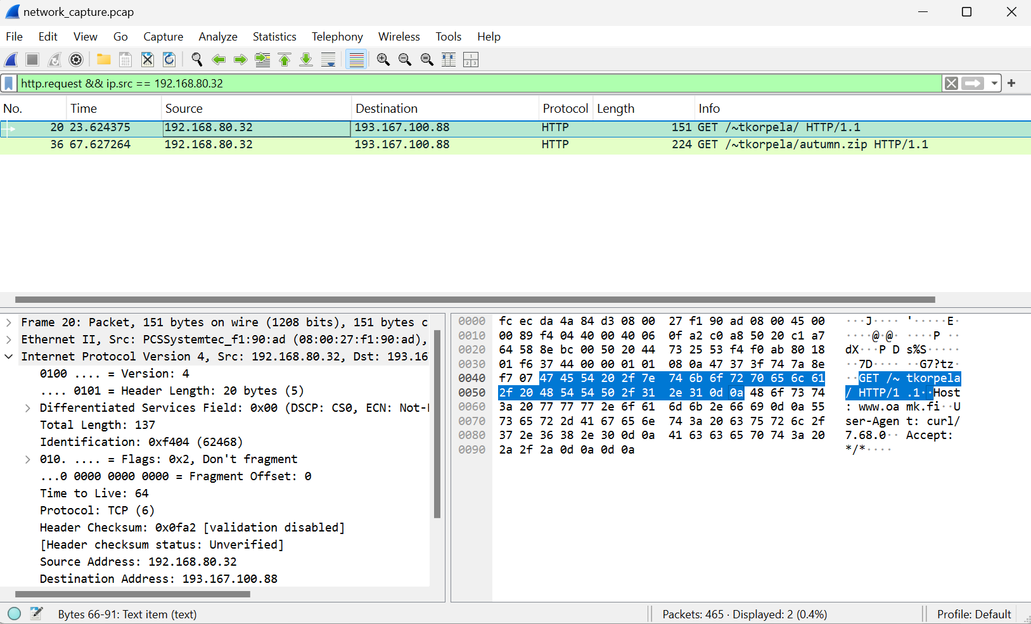
The first web page visited by host 192.168.80.32 was:
http://www.oamk.fi/~tkorpela/
The HTTP User-Agent string used to access the web server was: curl/7.68.0
  - What is the hostname in “Host:” field of the HTTP GET request sent by 192.168.80.32?
Host: www.oamk.fi
The hostname in the "Host:" field of the HTTP GET request was www.oamk.fi.

  - What is most likely the default DNS server (the IP address) used by the host 192.168.80.32?
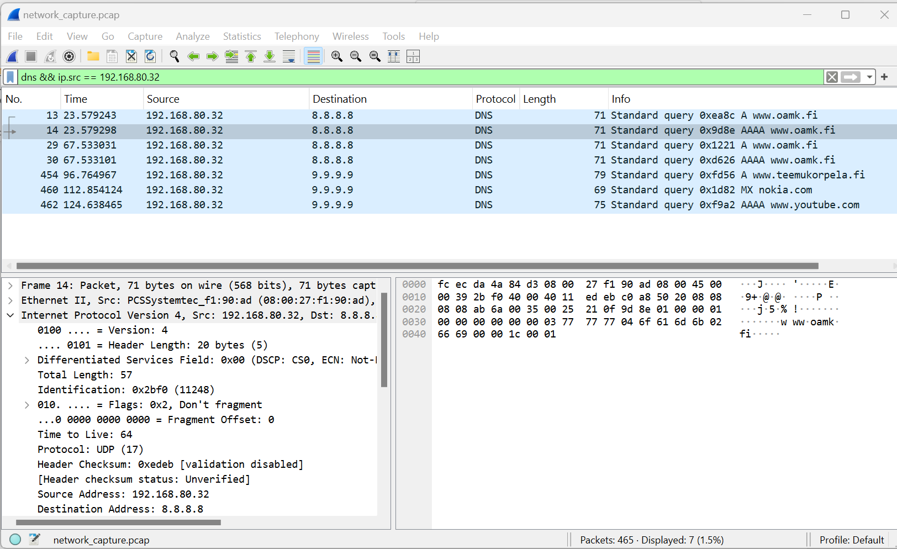
The most likely default DNS server used by host 192.168.80.32 is 8.8.8.8. The first DNS requests in the capture were sent to 8.8.8.8, while later DNS requests were also sent to 9.9.9.9.
  - Use Wireshark’s file/export objects/HTTP feature to extract the ZIP file which was downloaded from the web server 193.167.100.88. What is inside the ZIP file?
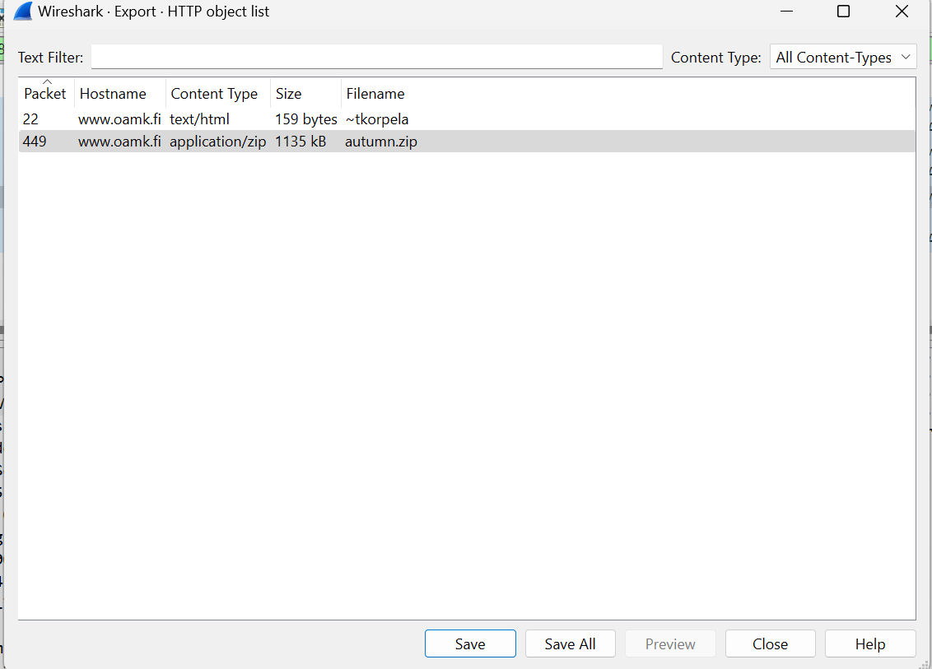
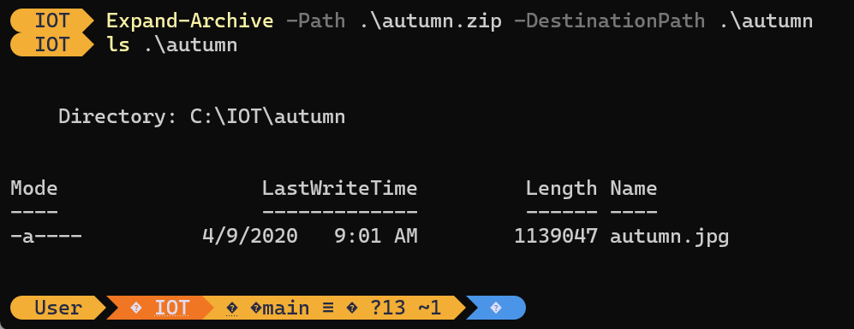
The ZIP file contained one image file named autumn.jpg.

  - Host 192.168.80.32 sent DNS requests to host 9.9.9.9. What are the requests?
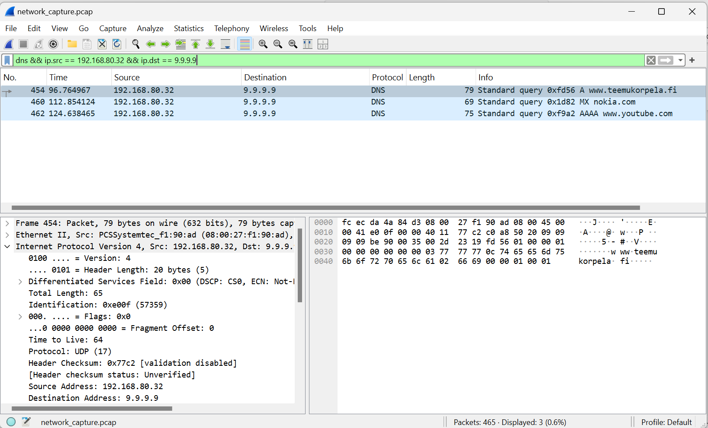
Host 192.168.80.32 sent three DNS requests to 9.9.9.9:
1. A request for www.teemukorpela.fi
2. MX request for nokia.com
3. AAAA request for www.youtube.com

- Create a new JSON file with any text editor. JSON file should contain data for at least two houses and related IoT sensor data. Each house must have few sensors with following information and some random data for each sensor. Something like this:
House:
- IoT sensor:
- sensor ID number
- location description
- notes about sensor
- unix epoch timestamp
- sensor values:
- value nnn
- value nnn
- value nnn
- Validate your JSON file with validator: jsonlint.com or jsonformatter.curiousconcept.com
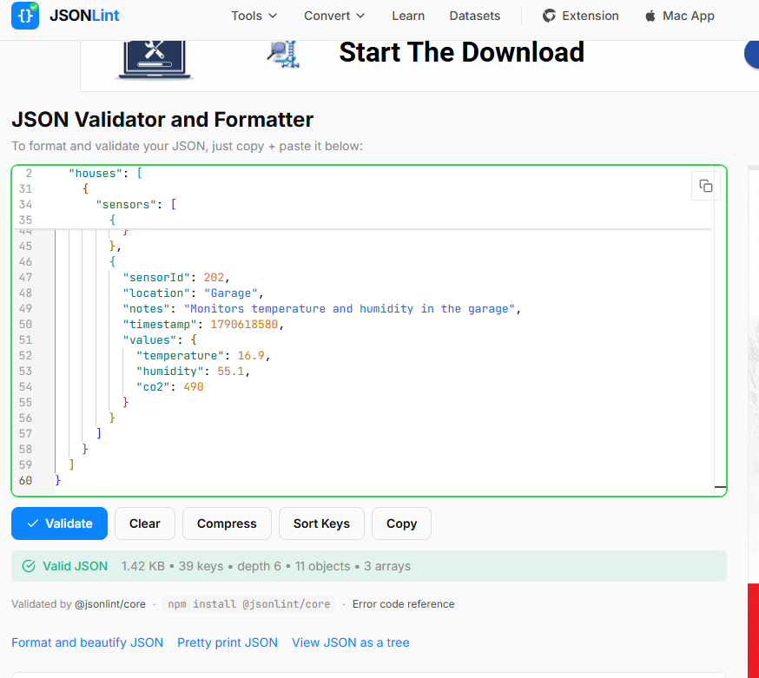
GraphQL is an open-source query language for APIs and a server-side runtime. It allows a client to request exactly the data it needs from an API. GraphQL uses a strongly typed schema to describe available data and supports queries for reading data, mutations for changing data, and subscriptions for real-time updates.

- What is GraphQL? Also, check this traffic and parking API documentation from Oulu (extra task uses this API)
The Oulunliikenne GraphQL API provides public traffic data for the Oulu region in JSON format. The available data includes traffic cameras, traffic measurement stations, parking garages, road weather stations, roadworks, maintenance information, traffic announcements and traffic-flow information. The API can be queried using GraphQL requests.

I also tested the Oulunliikenne GraphQL API using the carParks query. I requested only the name field, and the API returned parking locations in JSON format. This demonstrates an important GraphQL feature: the client can request only the specific fields it needs.
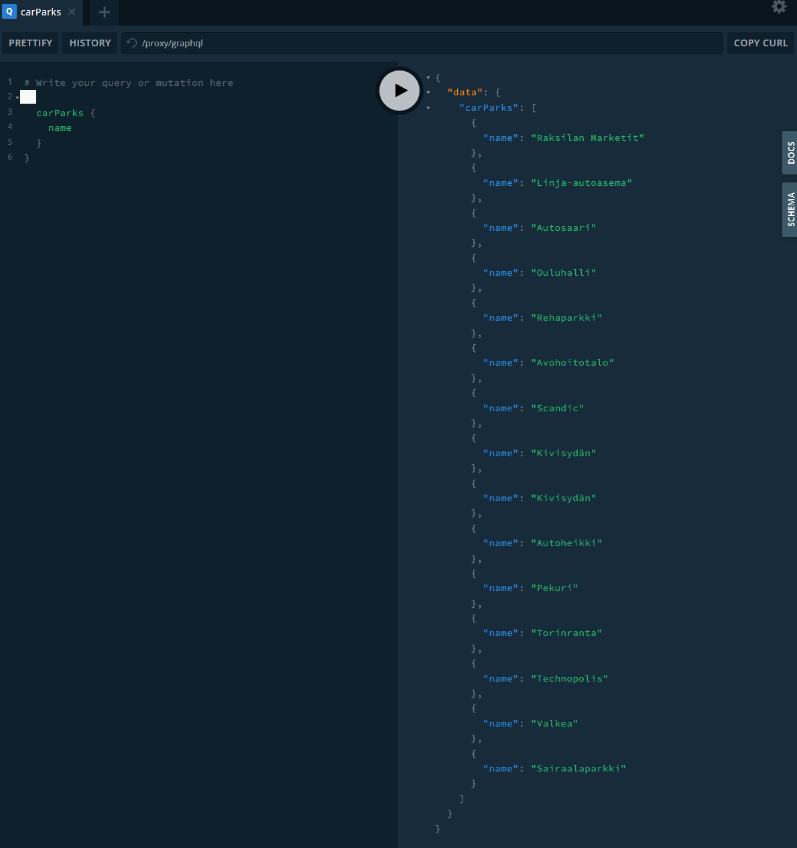

- Install Cmder (or some other toolset where you have Curl or similar tool to make HTTP requests from command line or application.) Use Curl to fetch XML formatted weather data from FMI:
curl -s -L "https://opendata.fmi.fi/wfs?request=getFeature&storedquery_id=fmi::observations::weather::timevaluepair&place=oulu&timestep=100&parameters=temperature"
- Inspect and validate the received XML data with www.w3schools.com/xml/xml_validator.asp
I used curl.exe to download XML-formatted temperature data for Oulu from the FMI Open Data service and saved it as fmi_weather.xml. I inspected the XML file in PowerShell and then validated it using the W3Schools XML validator. The validator reported "No errors found", confirming that the XML syntax was valid.
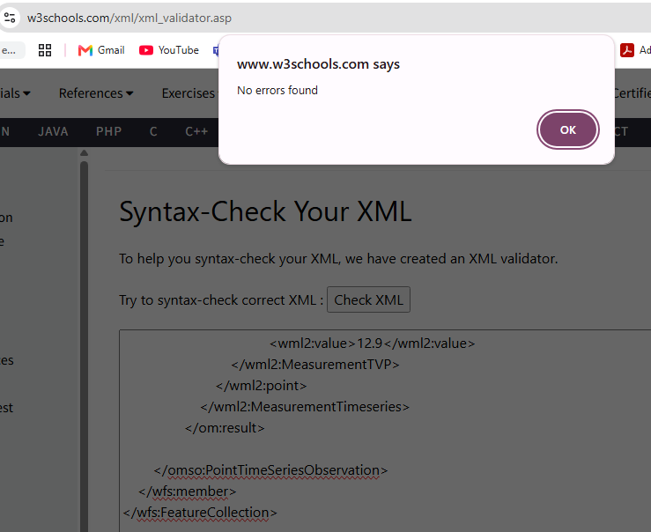
- Decode this base64 encoded message with any tool(s) you prefer:
SGVsbG8gdGhlcmUgT2FtayBzdHVkZW50ISBBcmUgeW91IGhhdmluZyBmdW4gbm93Pz8/
Hello there Oamk student! Are you having fun now???
- Encode this string:“I love data processing challenges!” with base64 encoding
SSBsb3ZlIGRhdGEgcHJvY2Vzc2luZyBjaGFsbGVuZ2VzIQ==
- Describe the difference between request-response and publish-subscribe communication models
In the request-response model, a client sends a request directly to a server and the server sends back a response. HTTP commonly uses this model.
In the publish-subscribe model, a publisher sends messages to a topic through a broker. Subscribers receive messages from the topics they have subscribed to. The publisher and subscriber do not need to know each other directly, which makes the communication more flexible and suitable for IoT systems.

- Try MQTT websocket demo application
  - Subscribe to some existing topic(s) in HiveMQ demo service
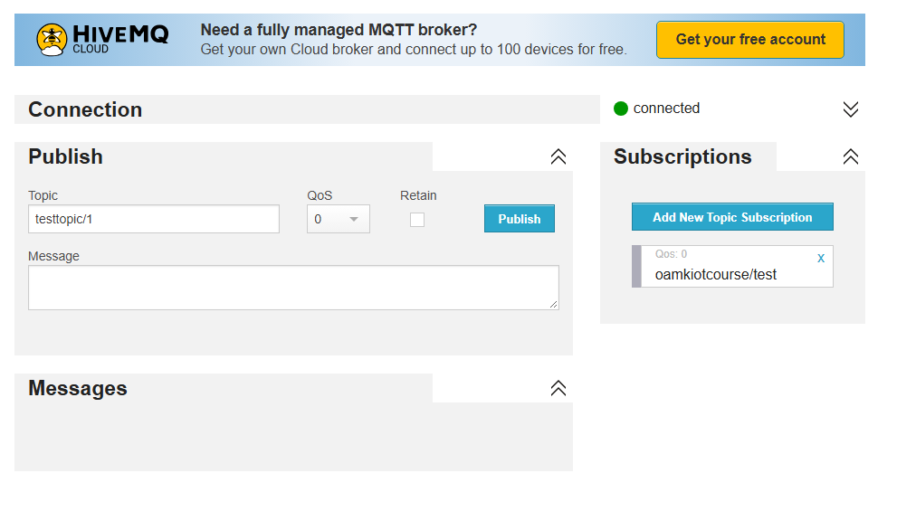
  - Publish some messages to the topic(s) you subscribed
I tested the HiveMQ MQTT WebSocket client. I connected to the MQTT broker and subscribed to the topic oamkiotcourse/test with QoS 0. I then published the message "Hello from OAMK IoT course!" to the same topic. Because I was subscribed to that topic, the published message appeared in the Messages section. This demonstrated the MQTT publish-subscribe communication model.
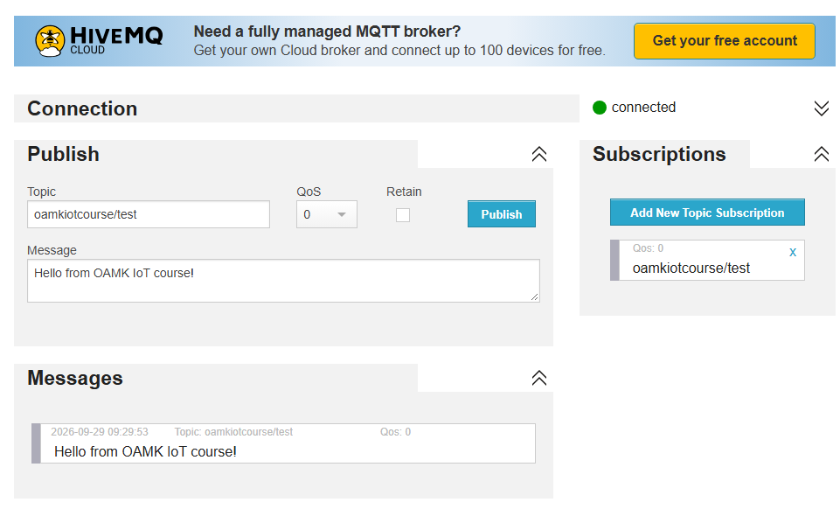

- Explain what are MQTT retained messages
An MQTT retained message is a message published with the retain flag enabled. The MQTT broker stores the latest retained message for a topic. When a new client subscribes to that topic, the broker sends the stored message immediately. This is useful for providing the latest known state, such as the current temperature or device status, without waiting for a new message.
- List shortly some reasons why MQTT may be better than HTTP for IP-based IoT communication? (For example: HTTP vs. MQTT: A tale of two IoT protocols and MQTT Vs. HTTP: Understanding the Differences)
MQTT may be better than HTTP for many IoT systems because it has lower message overhead and is designed for lightweight communication. It supports publish-subscribe messaging, so one message can be delivered to many subscribers. MQTT can keep one TCP connection open for two-way communication, which reduces repeated connection overhead. It also provides useful IoT features such as QoS levels, retained messages, message queuing and Last Will messages. These features can make MQTT more efficient and flexible for devices that send frequent small messages.
- What is CoAP?
CoAP stands for Constrained Application Protocol. It is a lightweight application-layer protocol designed for resource-limited IoT devices and low-power networks. CoAP follows a request-response model similar to HTTP, but it is designed to use less bandwidth and processing power. It commonly uses UDP instead of TCP, which helps reduce communication overhead in constrained IoT environments.
- What is 6LoWPAN?
6LoWPAN stands for IPv6 over Low-Power Wireless Personal Area Networks. It allows IPv6 packets to be used over low-power wireless networks such as IEEE 802.15.4. Because these networks have small frame sizes, 6LoWPAN uses techniques such as header compression and fragmentation to make IPv6 communication possible on constrained IoT devices.
- What is IETF ROLL?
IETF ROLL stands for Routing Over Low-Power and Lossy Networks. It is an IETF working group that focuses on routing solutions for networks made of constrained devices, such as sensors and IoT nodes. These networks often have limited power, memory and bandwidth, and their wireless links may be unreliable. ROLL developed the RPL routing protocol for these environments.

- Describe IETF RPL protocol?
RPL stands for Routing Protocol for Low-Power and Lossy Networks. It is designed for constrained IoT and sensor networks where devices have limited power, memory and bandwidth, and wireless links may be unreliable. RPL builds a routing structure called a DODAG, where devices select suitable parent nodes and forward traffic towards a root node. It is designed to support efficient IPv6 routing in low-power and lossy networks.
- Why classic computer network protocols like TCP/IP, data formats such as JSON and XML, and security systems like (PKI/HTTPS) won’t usually work at all or are not very optimal to be used in resource limited wireless sensor networks (low power and lossy networks)?
Classic Internet technologies can be too heavy for resource-limited wireless sensor networks. Small IoT devices may have limited memory, processing power, battery capacity and network bandwidth. TCP and traditional Internet protocols can create extra communication overhead. JSON and especially XML may increase message size compared with more compact data formats. Security systems such as PKI and HTTPS can also require more processing, memory and communication because of encryption, certificates and connection setup. In low-power and lossy networks, smaller packets and simpler protocols are often preferred to reduce energy use, bandwidth use and processing requirements.
- What is the MTU challenge for IPv4 and IPv6 over common wireless low power and lossy wireless connections (Hint: Research Zigbee/IEEE 802.15.4 and Bluetooth MTU vs IPv4 or IPv6)?
Low-power wireless networks often have much smaller frame sizes than normal IP networks. For example, IEEE 802.15.4 has a maximum frame size of 127 bytes, while IPv6 expects a minimum MTU of 1280 bytes. Therefore, a full IPv6 packet cannot fit into one IEEE 802.15.4 frame.
This creates an MTU challenge because IP packets may need fragmentation, header compression and reassembly before they can be carried over the low-power wireless link. 6LoWPAN was designed to help solve this problem by compressing IPv6 headers and supporting fragmentation. Similar MTU limitations can also exist in Bluetooth-based low-power communication, where the link-layer packet size can be much smaller than normal IPv4 or IPv6 packets.
- Compare and list few HTTP/1.1, HTTP/2 and HTTP/3 differencies and features
HTTP/1.1 uses TCP and mainly handles requests in a more sequential way. Browsers often need several TCP connections to improve parallel loading, and it can suffer from head-of-line blocking.
HTTP/2 also uses TCP, but it introduces binary framing, multiplexing and header compression. Multiple requests and responses can share one connection, which reduces overhead and improves performance.
HTTP/3 uses QUIC over UDP instead of TCP. It keeps multiplexing but reduces the effect of TCP head-of-line blocking. QUIC also provides faster connection setup and encryption by default.
In short, HTTP/1.1 is simpler but less efficient, HTTP/2 improves performance using multiplexing and compression, and HTTP/3 improves performance and reliability further by using QUIC over UDP.

- Use Chrome or other Chromium based browser and it's developer tools (F12), and access the course web page tl.oamk.fi/iot/. From the developer tools network tab, select the main page: iot/ and check the response headers. Answer:
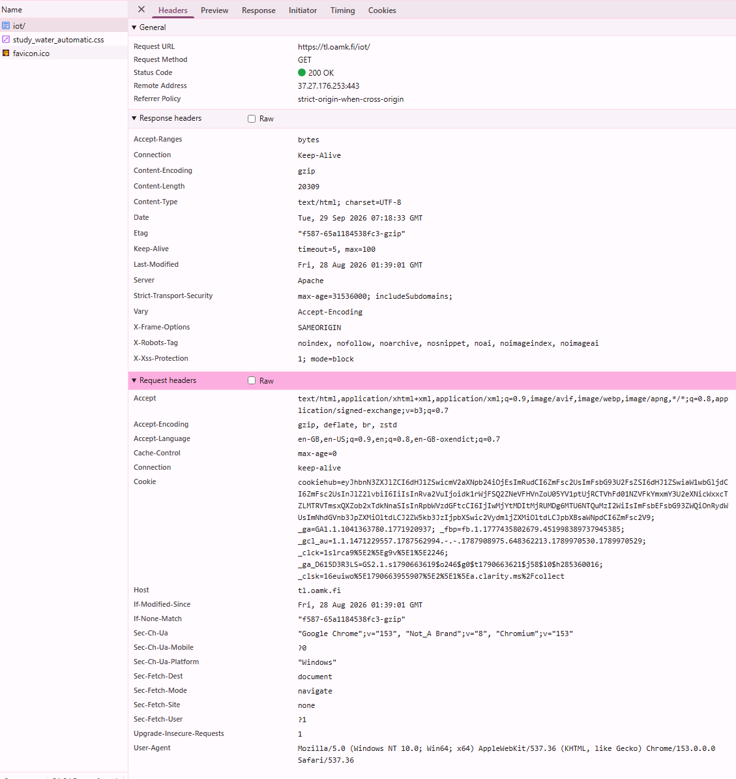

  - What is the connection type? Keep-Alive
  - What is the server software the web server announced? Apache
  - Was any compression / encoding being used? (content-encoding) gzip, so compression was used
  - Is there X-Xss-Protection set in the response? Yes, set to "1; mode=block"
  - Is there Strict-Transport-Security set in the response? Yes, set to "max-age=31536000; includeSubdomains;".

- What is Head-of-Line blocking challenge/problem?
Head-of-Line blocking happens when one delayed request or packet causes other requests or data behind it to wait. In HTTP/1.1, one slow response can block later responses on the same connection. HTTP/2 improves this at the HTTP layer by using multiplexing, but it still uses TCP. If one TCP packet is lost, the whole TCP connection may have to wait until that packet is retransmitted. HTTP/3 reduces this problem by using QUIC, where streams are handled more independently, so a lost packet in one stream does not block all other streams.
- What is reverse proxy. List some advantages and features
A reverse proxy is a server that sits in front of one or more backend servers. Clients send their requests to the reverse proxy, and the proxy forwards the requests to the correct backend server.
Advantages and features include load balancing, hiding backend servers, SSL/TLS termination, caching, access control, request filtering and improved security. A reverse proxy can also distribute traffic between several servers and provide one public entry point for multiple services.
- What is Web application firewall (WAF). List some advantages and features
The provided course sources do not directly explain Web Application Firewalls (WAF), so this question needs an additional approved source or teacher material before I can give a source-based answer.
- What are Websockets?
WebSockets provide two-way communication between a web browser and a server over one persistent connection. Unlike normal HTTP request-response communication, both the client and server can send data whenever needed after the connection is established. WebSockets use TCP and are useful for real-time applications. In IoT systems, MQTT can also run over WebSockets, which allows web browsers to communicate with MQTT brokers.

- What is HTTP long polling?
The provided course sources do not directly explain HTTP long polling, so this question needs an additional approved source or teacher material before I can give a source-based answer.
- Use this tool to check few websites whether the server supports HTTP/2: tools.keycdn.com/http2-test. Two examples: www.kaleva.fi and www.oulu.fi
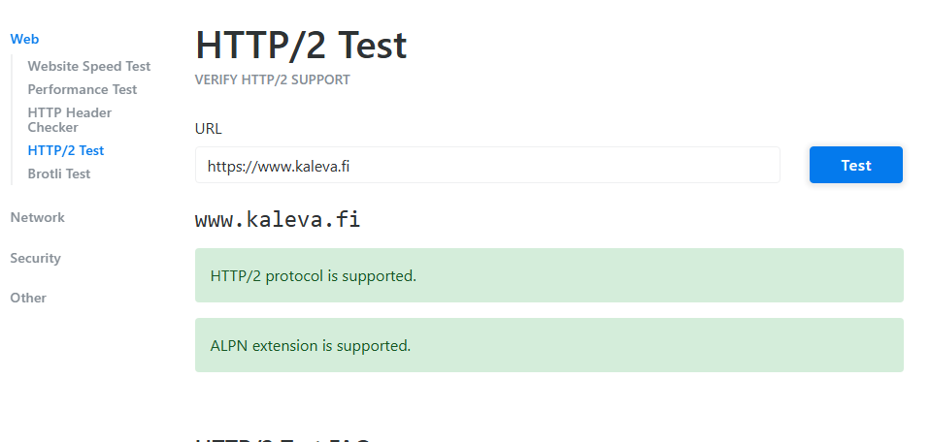
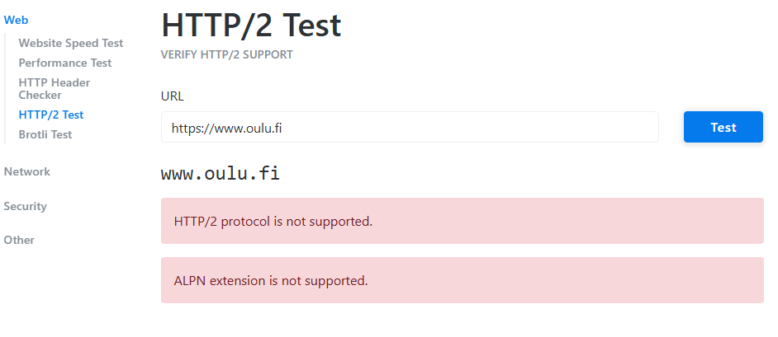
I tested www.kaleva.fi and www.oulu.fi using the KeyCDN HTTP/2 Test tool.
www.kaleva.fi supports HTTP/2 and ALPN.
www.oulu.fi does not support HTTP/2 and does not support ALPN.

- Study Google Firebase documentation and advertisements. Think and list examples how to use Firebase ecosystem with Android application(s) or with some IoT other system?
- Use hivemq.com open MQTT broker service with Python to publish MQTT messages. Use this very basic Python MQTT publish example. Change the MQTT channel name to something different if the script complaing about the authentication.
  - Install Paho MQTT library to your Python development environment. With apt install (Linux) it should be something like this: apt install python3-paho-mqtt Note: Using venv or other virtual environment with Python is strongly recommended. With virtual Python environment it is something like (in Linux systems):
  - python3 -m venv testing
  - source testing/bin/activate
  - cd testing
  - pip install paho-mqtt
  - wget https://tl.oamk.fi/iot/dl/hivemqtt_example.txt
  - mv hivemqtt_example.txt hivemqtt_example.py
  - ... edit the script if necessary with nano, vim or so...
python3 hivemqtt_example.py
  - Use web browser to connect HiveMQ websocket client interface. After connecting, subscribe to oamkiotcourse/# channel (# is wildcard to receive all data)
  - Modify the example Python code and publish some random data to the oamkiotcourse (or some channel of your own). Example code and websocket client should look something this
  - Analyse your Python MQTT client traffic with Wireshark (or with tcpdump if using some Linux server). For example, this packet capture example file is from this kind of MQTT publish message. From your Wireshark capture:
    - What is the destination IP address?
    - What are the source and destination TCP ports?
    - Can you find published data as plain text from your captured traffic sample?

- Ad
- Asd
- A
- Da
- D
- As
- Da

